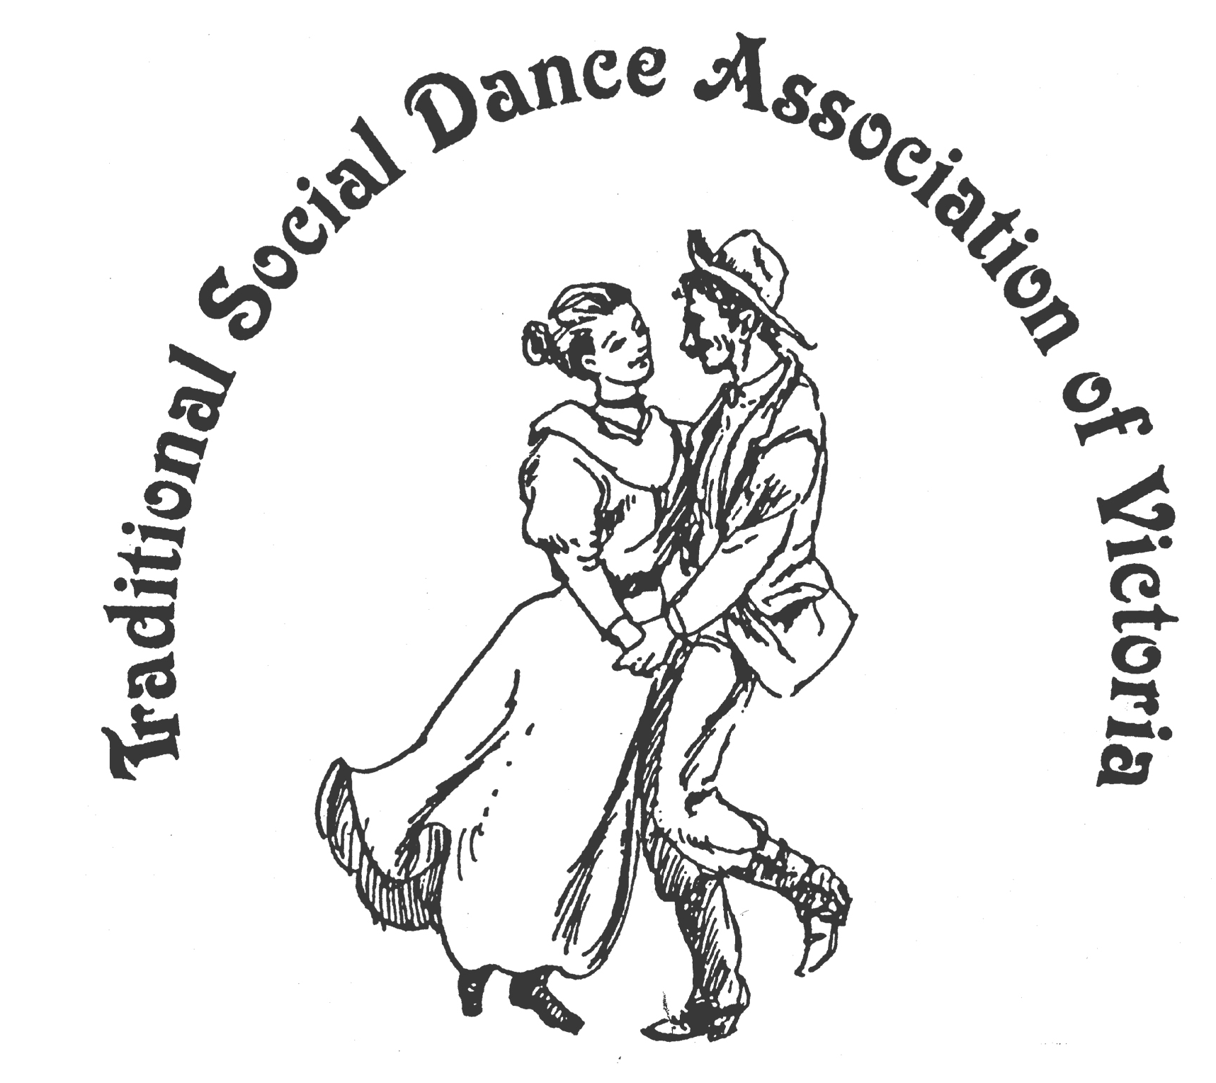

TSDAV’s Spring Bulletin Oct 2012

News - Reviews - Reminders

Greetings once again to all TSDAV members and supporters.

Well, Spring has sprung, and the Equinox has come!
The days are lengthening, and warming (mostly!), as our financial year gets underway and we leave the Winter months behind us. We commenced our year with the annual Old Time Tea Dance in July, held the obligatory AGM, and followed up quickly with the Wattle Day ‘Day of Dance’ out at Ringwood with the VFMC. Planning for our Spring Dance Weekend at Portarlington in November is all but complete, and once again, we will be having a Christmas Hoedown for our December social.
We look forward to your continuing support at our functions and wish you ‘Happy Dancing’ wherever it be.

... ooo OOO ooo ...

The OLD TIME TEA DANCE July 28th
This event was again held at St David’s Uniting Church Hall, Brunswick East. 4:30-9:30 pm.
It was wonderful to attend the TSDAV and Folk Song & Dance Society’s shared event, with the fantastic music of The Gay Charmers. The Band formed in the late 1950s, their name coming from feeling Gay (happy) and their home town, Lake Charm. This year Peter Ellis was unable to attend, he was of course missed, but the band was joined by Margaret Hogan from the Bendigo Bush Music Club. They were also joined by Greg O'Leary for several tunes. It was such great music to dance to.
We danced the time away to our favourite Waltzes and Quadrilles, and enjoyed the Grand March into The First Set. Edwardian style skirts swirled to the music. We also enjoyed a lively Virginia Reel, Highland Schottische, and Eightsome Reel. It was noticeable that not as many of us partake in dancing the Polkas and Mazurkas, (for myself: a few joints wearing out from having so much fun doing Polka Mazurkas in my earlier days of dancing).
Our MCs Robin Simpson and Carol Rowe created an enjoyable atmosphere, and thanks also to our callers who included Michael Tracey and Jo White. It was great to have Jo dancing and calling the Lancers from the floor.
We had enjoyable Tea Time treats with lots of social chatter. My first question at our supper times is always "which cake did Rod Mattingley make?'', as it’s always such a treat.
It was also good to have some new faces, and some Gay Charmers’ followers from Gippsland, enjoying our Tea Dance. I and many others will be looking forward to it again next year.
Marion Stabb.

... ooo OOO ooo ...

AGM Our AGM was held on Sunday 19th August, at the Church of Christ Hall, The Avenue, Surrey Hills.

Membership fees remain the same, and fell due from this date.

Member’s discounts apply at our events.

Your new Committee is - President Bruce McClure 9772 8500

Secretary Heather Larsen 9808 4869 Treasurer Norm Ellis 9888 5332

Marion Stabb (Portarlington w/e) 9439 7100 George Ansell (Dance Comp.) 9890 5650 Margaret Monkhouse (VP) Judith Baillie Kathy Cox

We are URGENTLY seeking someone to help with our web-site,
if you are able to help us, please let us know.

Copies of our Annual Report for 2012 are available upon request to the Treasurer.
... ooo OOO ooo ...

“WATTLE DAY” 1st September – First Day of Spring
For the first day of spring the TSDAV and VFMC combined to promote Australian music and dance with a dance-out in the East Ringwood Market, dance and music workshops, and an evening dance. The day proved most enjoyable and the evening particularly well attended. The day proved highly successful and has confirmed Wattle Day a fixture in our calendar.
The weather was fine and warm when sprigs of wattle decorated dancers and musicians for our dance in the market, and where several mothers and children joined in the fun, while Norm Ellis called simple dances and dance variants suitable for the occasion.
The ‘Wattle’ theme was in evidence for the afternoon, with a music workshop and a singing workshop in the Scout Hall and 2 dance workshops of Australian dances in the Senior Citizens Hall, and also a PA for dance workshop. Peter Ellis’s music workshop concentrated on how to play music for dance. 10 easy dances mostly by Mike Waters made up the first dance workshop presented by Norm Ellis and attended about 17 dancers. The second workshop would have been presented by Val Wilson from Albury/Wodonga, but as she was unable to be there, Norm Ellis and Bruce McClure challenged about the same number of dancers as before, with 8 or 9 dances in various formations, including 3 of Val Wilson’s devising, and 3 more from Mike Waters.
The East Ringwood dance in the evening had a distinctly Australian flavour and attracted about 70-85 people, a tribute to the VFMC's promotion of the day! With music provided by Blackberry Jam, a spot act of Marg Somerville’s Wattle Day song, and inspiring rendition of “Eucalyptus” sung and danced as a ‘round’ by all, the whole being led by Norm Ellis, the evening passed quickly and joyfully.
George Ansell

Wattle Day Singing Workshop - with Margaret Creighton.
This year I missed the 2nd dance workshop of Wattle Day, to attend the Singing Workshop with Margaret Creighton. Margaret is involved with several Choirs and it was a great workshop, singing Australian material to help us celebrate Wattle Day. We had 9 singers in all, and after warming up we sang 5 enjoyable songs, breaking into some three part harmonies.
The group comprised some experienced singers, and some just singing for the joy of it. We sang along to "Along the Road to Gundagai", "Botany Bay", "Wonthaggi Mine Whistle Song" and a favourite of mine "Hey Rain".
It was an enjoyable workshop, and singing for joy gives one a wonderful feeling. A big ‘Thank You’ to Margaret, it was great having a singing workshop as part of the program.
Marion Stabb.

... ooo OOO ooo ...

Upcoming Events:
Spring Dance Weekend
9th – 11th November 2012
Parks Hall Community Centre, Portarlington

Marion and your committee have organised another great program for this year’s event.
Our featured presenters are Bill & Margaret Winnett, from Sydney. Well known in Irish dancing circles around the country, regulars at the National & Bundanoon, always lively & enjoyable, they are giving 2 workshops, with the intriguing titles of: “From Cork to the Grand Hotel, Killarney” & “Under the Wing”.
We also have Jim & Ingrid Rehle-Williams, to take us dancing Bavarian style, Ian Kendall, with more Welsh delights, and Norm Ellis with a special selection of dances for Remembrance Day (Sunday 11th).
Ray & Joan Mundy are taking the ‘Irish Dance Tunes’ music workshop. The line-up is completed by Claire Stoneman, a new face to Melbourne dancers, but well known in Canberra dance circles, a polished caller and presenter, and composer of ‘Gates of Moy’ & ‘Trading Places’ (both Dance Comp. winners in 2004).

6 dance workshops, 1 music workshop, 3 Interstate & 3 Melbourne teachers,
Sat. night Social - “A Touch of Red – the Colour of Romance”

Bookings for the weekend are now open - see separate flyer!

 Early Bird pricing - on or before Monday 15th October

... ooo OOO ooo ...

2013 New Dance Competition ...further call for entries . . .

Entries are now being received for the Dance Composer’s Competition.
There will again be two judged categories:
* General Social Dance, * For More Experienced Dancers.

New entries are to be sent to george.ansell@bigpond.com or c/- 62 Wellman St. Box Hill South, Victoria, 3128 by 8th February 2013. Please contact George for a copy of the Rules & Conditions.

... ooo OOO ooo ...

For Your Diary –
Our end of the year social is on the Sat. 8th December. 2012
And once again we present our legendary Christmas Hoedown !
a classic mix of American, Contra & Colonial.
Dancing from 8 to 11, followed by Supper!

Ashburton Uniting Church Hall, 3 Ashburn Grv. Ashburton. Melways 60 D 10

a fun night of dancing for all! - see separate flyer!

... ooo OOO ooo ...

“Dancing at The Eleventh Hour” an occasional series of Dance Workshops

We meet at : The Eleventh Hour Theatre Hall, cnr Gore & Leicester Sts, Fitzroy.
( just South-West of the Smith S.t & Alexandra Pde ( Eastern Fwy.) intersection.
Dates for 2012, - 1st July, 29th July, 2nd Sept, 28th Oct. & 2nd Dec. @ 2pm – 5 pm
On 28th Oct. we will be previewing some of the dances on the
Portarlington weekend program
.
All dancers are welcome Inquiries: Norm Ellis 9888 5332.

... ooo OOO ooo ...

Other Dancing Events of interest . . .

There is now a regular Contra Dance in Northcote,
on the last Sunday of the month. 7:30 – 10:00pm $12 / $7
Jul 29 Aug 26 Sep 30 Oct 28 Nov 25
@ Uniting Church Hall, 251 High St. Northcote.
www.facebook.com/Contradition

English Country Dancing – a farewell dance for Ken Morgan
Tuesday 30th October 7:30 – 10:30 pm
@ Church of Christ Hall, 1 The Avenue, Surrey Hills
for more info, contact George Ansell, 9890 5650

The next VFMC Woolshed Ball will be on Saturday 13th October 2012
at the St David's Uniting Church Hall,
Cnr Mont Albert Rd & Burke Rd, Canterbury,
featuring Blackberry Jam
All welcome for an evening of great fun.

The Melbourne Colonial Dancers' Spring Ball for 2012
will be held at Preston Town Hall at 8pm on Saturday 17 November.

The theme will be "Spring into Summer".

