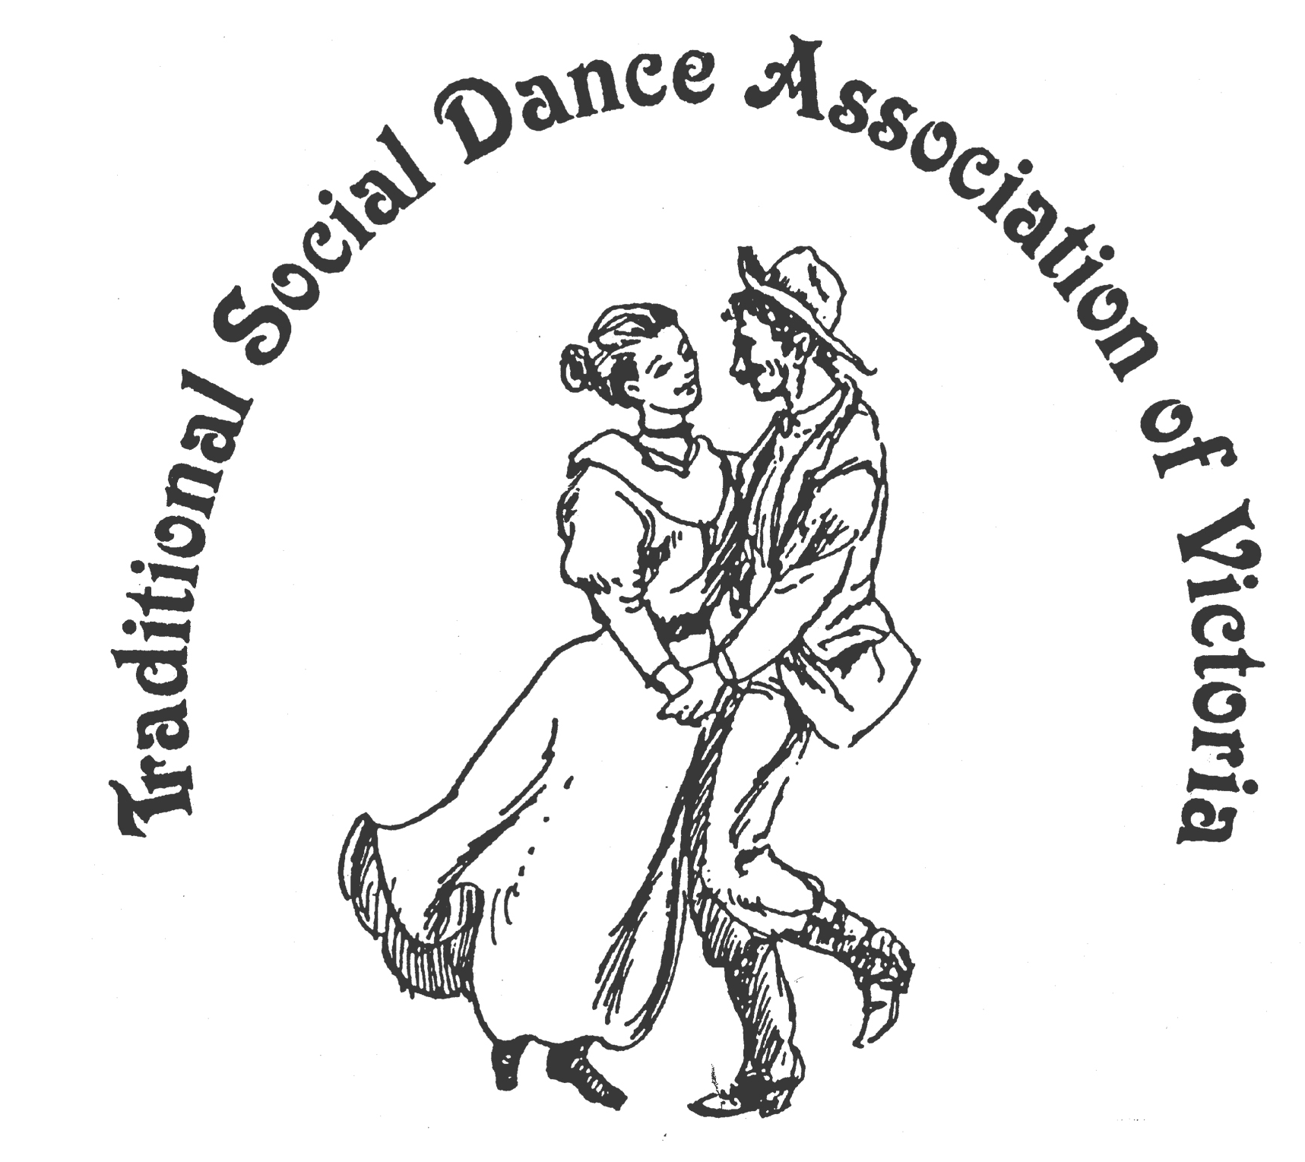

TSDAV’s Bulletin July 2012

News - Reviews - Reminders

Greetings once again to all TSDAV members and supporters.

We may be in the depths of winter, but we are now past the shortest day,
Easter (& the NFF) are now well behind us, and there is lots of dancing to look forward to.

TSDAV @ the National –
Once again, our annual Dance Composer’s Competition was judged as part of the National Folk Festival. This year it was held in the Mallee, on Easter Sunday morning, at a slightly later timeslot. It was well attended, and the standard of entries was high. - see separate report.
Norm ran a dance workshop (Fun New Dances for All) on our behalf, and had much better luck with the programming. Last year he was up against ‘The Bushwackers’! It drew a good crowd and ran smoothly, thanks in no small part to the fine musicianship of the band led by Denise Hibbs. The dances used were from our recent competitions, and it looked like those present were indeed having fun dancing them!
This year we also had a dance display on the ‘Piazza’. It aimed to highlight the connection between ‘the inspiration’ and ‘the dance’, and featured dances from Section B of our Competition. It was on late Sunday afternoon, with not many watching. But amongst those present was the composer of 2 of the dances featured, John Short, who was generous with his praise:
“I really enjoyed the TSDAV display.... Very nicely danced all round, and thanks Norm for your explanations of the inspiration of the dances. A biased opinion of course, but I especially enjoyed The Flying Doctor. It was neatly danced and you made the four half reels of three as couples look so easy. The "mantle of safety" section also looked very good. I also enjoyed the six couple version of the Casuarina Waltz. J.S.”
I wish to thank both our dancers and musicians for the magnificent effort they put in.
I was well pleased by the result! Norm Ellis.

We have applied for a dance workshop at next year’s National Folk Festival,
intending to promote dances from various TSDAV publications.

Dance Composer’s Competition – Canberra, NFF 2012

An embarrassment of riches – this year we were delighted (if somewhat overwhelmed) with the number of entries we received for our annual Dance Composer’s Competition. So much so that we had far too many to be judged at the National, and had to prevail upon submitters to limit themselves to just one dance each!
It also turned out that the standard of entries was such that the judges had trouble in selecting a clear winner!
In Section A (general social dance) Jane Bullock’s “Spooky Corners” just nudged out Gary King’s “Needles to Say”, while Keith Wood’s “Etica Reel” and Lorraine Findlay’s “Come and Dance with Me” made up a fine selection. Section B (for more experienced dancers) was ever tighter, with the judges declaring a tie, over a very close runner-up! Honours were shared between John Short’s “Snowy River Galop” and Margaret Crichton’s “Three’s Company”, over Norm Ellis’s “Wattle Valley Waltz”, and with Felicity Hattingh’s “Fool on The Hill” making up this selection. Congratulations to all.
Our thanks also go to Lynne Stone for being our chief judge, to Bruce McClure and Sheree Greenhill, the other two judges, and to Paul Wayper and Don Richmond, for instructing and calling the dances.
Jane and Margaret were presented with their Trophies at the VFMC’s Woolshed Ball, while John received his at the Bundanoon ‘DanceFest’ (Queen’s Birthday weekend).
Entries for next year’s competition will close on 8th Feb.2013.
We have revised the rules so that entrants will no longer need to specify the category for their dance: that will now be at the discretion of the judges, and be judged accordingly.
These updated rules now appear on the web-site, under the ‘DANCES’ tab.
George Ansell, Co-ordinator of the Dance Composer’s Competition.
Reflections of the National from a first timer –
As a first timer at the National I thought it was terrific. The events in all areas were of the highest order whether that be music, dance, song, circus, poetry ….the list goes on. It covered the needs of all interests and ages. The overseas performers were sensational and the variety exceeded my expectations.
Some of the performers have been around for as long as the festival e.g. Mike Jackson, who sang with his wife Michele when I took my children, and now my youngest is 25 !!!……
The dance items on the Piazza were a delight and it is a pity the audience was not larger on occasions, as so much time and effort goes into all the displays, not just ours!
Next year I will be able to make comparisons, but this year it was purely good fun all the way, and the best of Canberra weather into the bargain. Judith Baillie.

Matt Harriage, from Borderline Kaylee, has written an excellent report on the Irish dance component at the National Folk Festival. SIAN (Set dancing in Australia and New Zealand) April 2012.
It includes high praise for the workshop and Ceili run by Bill and Margaret Winnett, who are our featured presenters at our Portarlington dance weekend in November. - see separate item.

... ooo OOO ooo ...

2013 New Dance Competition first call for entries . . .

Entries are now being received for the Dance Composer’s Competition.
There will again be two judged categories:
* General Social Dance, * For More Experienced Dancers.

New entries are to be sent to george.ansell@bigpond.com or c/- 62 Wellman St. Box Hill South, Victoria, 3128 by 8th February 2013. Please contact George for a copy of the Rules & Conditions.

... ooo OOO ooo ...

While many of you were no doubt enjoying all things Celtic at Portarlington on the Queen’s Birthday long weekend, Norm was carrying the TSDAV banner at the 4th Bundanoon ‘DanceFest’. Located in the NSW Southern Highlands, about midway between Canberra & Sydney, Bundanoon is purely a dancers w/e. It runs up to 3 concurrent venues throughout the day, coming together at night with just the one dance in the main hall. (The Sunday night is a big ‘dress-up’ Ball) Run by ‘Bush Traditions’ – check out their website to see the breadth of workshops & presenters - all workshops are backed with live music. Norm continued his NFF theme of “Fun Dances” for his workshop, while Peter Ellis, holding up the Victorian presence, workshopped ‘Australian Old Time Social Dance’. With 26 workshop sessions in all, it certainly is a ‘festival for the feet!’
see - www.bushtraditions.org
... ooo OOO ooo ...
Upcoming Events:
Our next social is at the end of this month, on the Sat. 28th July.
And that is the annual “Old Time Tea Dance” featuring the music of “The Gay Charmers”.
Dancing from 4:30 to 9:30 ish !
St David’s Uniting Church Hall, 74 Melville Rd. Brunswick West.
Melways 29 C 6 at the same venue as last year.
it looks like a fun evening for all! - see separate flyer!
Tickets are available from the Committee.

... ooo OOO ooo ...

Plans for our combined event with the VFMC, to celebrate “Wattle Day” are well advanced.
Another ‘day of dance’, with a morning ‘dance-out’ at the East Ringwood market, followed by 2 afternoon dance workshops, and the evening dance, with “Blackberry Jam” Sat. 1st. September,
at the East Ringwood “Elderly Citizen’s Hall”, Laurence Grove, Melways 50 B 8
The VFMC will again be running afternoon singing & music workshops. - see separate flyer!

This year we have a special guest presenter, Val Wilson, from Albury/Wodonga. Val has been calling with Bush Bands since 1981, and teaches both music & dance in schools. With a background in Scottish dancing, she has devised a number of her own dances, and was actively involved in the TSDAV weekends in Yackandandah.
A rare visitor to Melbourne, and an opportunity too good to miss, we have also secured Val for our Sunday 2nd Sept. session at the ‘11th Hour’ where she will teach us some of her ‘Ragtime’ dances. (think Levi Jackson & Salty Dog Rags)
Val’s Wattle Day workshop will be: “Aussie Dances with a ‘Dash of Scotch’”
The other dance workshop will be: ‘Dancing for Fun – more Aussie Bush Dances”, and will be mostly by Mike Waters” – a collection of dances rarely seen in Melbourne, written by Mike, who is from Sydney’s Bush Music Club & Sutherland Shire Bush Dance Group.
After last year, Mike wrote: “It was great to hear of your ‘Wattle Day’ celebrations; which gave me great joy to know my dances were being enjoyed.”

... ooo OOO ooo ...

Spring Dance Weekend 9th – 11th November 2012
Marion and your committee have organised another great program for this year’s event.
Our featured presenters are Bill & Margaret Winnett, from Sydney. Well known in Irish dancing circles around the country, regulars at the National & Bundanoon, always lively & enjoyable, they are giving 2 workshops, with the intriguing titles of: “From Cork to the Grand Hotel, Killarney” & “Under the Wing”.
We also have Jim & Ingrid Rehle-Williams, to take us dancing Bavarian style, Ian Kendall, with more Welsh delights, and Norm Ellis with a special selection of dances for Remembrance Day (Sunday).
Ray & Joan Mundy are taking the ‘Irish Dance Tunes’ music workshop. The line-up is completed by Claire Stoneman, a new face to Melbourne dancers, but well known in Canberra dance circles, a polished caller and presenter, and composer of ‘Gates of Moy’ & ‘Trading Places’ (both Dance Comp. winners in 2004).

6 dance workshops, 1 music workshop, 3 Interstate & 3 Melbourne teachers,
Sat. night Social - “A Touch of Red – the Colour of Romance”

Bookings for the weekend are now open - see separate flyer!

... ooo OOO ooo ...

Your Committee: President Bruce McClure 9772 8500

Secretary Heather Larsen 9808 4869 Treasurer Norm Ellis 9888 5332

Marion Stabb (Portarlington w/e) 9439 7100 George Ansell (Dance Comp.) 9890 5650 Margaret Monkhouse (VP) Judith Baillie Kathy Cox

We are URGENTLY seeking someone to help with our web-site,
if you are able to help us, please let us know.

... ooo OOO ooo ...

We welcome Heather Larsen back after her major illness. It is so good to see her dancing again.

We also note with sadness and regret, the recent passing of our long term member & loyal supporter,
Susan Harrap, from Adelaide, whilst on her way to the UK.
Our deepest sympathy goes to Graham, her family & all her Adelaide dancing friends.

... ooo OOO ooo ...
For Your Diary -
AGM Our AGM has been set for Sunday 19th August. (Members will be advised of details later.)
Memberships will be due from this date. You can join at any event,
or post to our treasurer, Norm Ellis, 30 Glyndon Rd Camberwell 3124
Member’s discounts apply at our events.

... ooo OOO ooo ...

“Dancing at The Eleventh Hour” an occasional series of Dance Workshops

We meet at : The Eleventh Hour Theatre Hall, cnr Gore & Leicester Sts, Fitzroy.
( just South-West of the Smith S.t & Alexandra Pde ( Eastern Fwy.) intersection.
Dates for 2012, - 1st July, 29th July, 2nd Sept, 28th Oct. & 2nd Dec. @ 2pm – 5 pm
All dancers are welcome Inquiries: Norm Ellis 9888 5332.

Remember, we have a guest presenter, Val Wilson, with a special program on 2nd Sept.

... ooo OOO ooo ...

Review Peter Ellis has written a review of the new dance instruction booklet and companion music CD by 'Delia's Friends, titled ‘Dancers Banquet' - 'A Feast for the Feet'. It is a tempting collection of original dances in traditional English style. - see attached!

... ooo OOO ooo ...
STOP PRESS from Jenny Hibbens
Just thought you'd like to know that I've finally finished my thesis. Yeah !!!
However a more practical version is at this website -
http://oa.anu.edu.au/obituary/andrews-shirley-aldythea-14936
I was so pleased to have it accepted!
Thought you might like to see it and perhaps send it around the TSDAV, and any other groups that might be interested in Shirley (surely still a well known name!!)

The obituary version reads in part –

“Shirley began to learn ballet when at university, eventually taking lessons with Edouard Borovansky, from whom she learned about ‘character dances’. She joined Margaret Frey, another pupil of Borovansky, in her classes and the Unity Dance Group, which performed at events of the Australian Communist Party (CPA) and deepened her appreciation of Australian folk dance. Shirley played a part in establishing the Folk Song and Dance Society and the Victorian Folk Music Club, the latter encouraging her to begin researching how Australians used to dance in the nineteenth century. Her research led to the seminal book, Take Your Partners, and the production of three videos with Lucy Stockdale, entitled ‘How Australia danced last century’. She was an inspired teacher and leader of dance classes, and organised formal balls and regular dances for dance groups for the Traditional Social Dance Association of Victoria. Her research into dance and dance styles continued with the Victorian Dance Assembly until two weeks before her death.”

and is based on Jennifer's PhD thesis, 'Shirley Andrews: A Prismatic Life' (University of Melbourne, 2012).

Well done, Jenny.

... ooo OOO ooo ...

Other Dancing Events of interest . . .

There is now a regular Contra Dance in Northcote,
on the last Sunday of the month. 7:30 – 10:00pm $12 / $7
Jul 29 Aug 26 Sep 30 Oct 28 Nov 25
@ Uniting Church Hall, 251 High St. Northcote.
www.facebook.com/Contradition

International Folk Dance Workshop
with visiting popular Dutch teacher Andre van de Plas
Sunday 29th July, morning & afternoon sessions
@ Box Hill Senior Cit’s Centre, 74 Carrington Rd. Box Hill.
for registration enquiries, contact – Jan Turner 9434 3368 – jant@alphalink.com.au

English Country Dancing - with Delia’s Friends
Tuesday 31st July 7:45 – 10:15 pm
@ Church of Christ Hall, 1 The Avenue, Surrey Hills
for more info, contact George Ansell, 9890 5650

the 17th Annual Dinki Di Old Time Ball
Saturday 22nd September 2012 7pm until late!
@ Eaglehawk Town Hall, Bendigo.
Music by The Gay Charmers & Emu Creek
For further information contact – Mary Smith 5442 1153

... ooo OOO ooo ...

