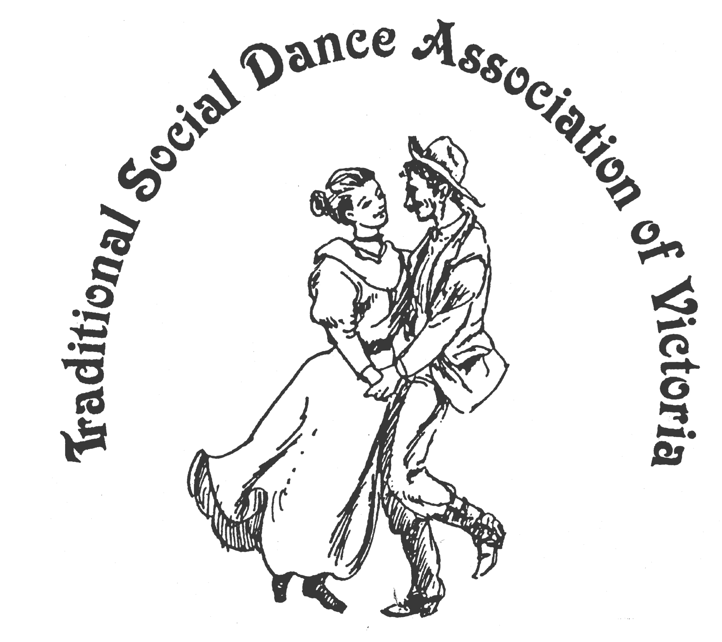

TSDAV’s Summer Bulletin December 2012

News & Reviews

Season’s Greetings and Best Wishes to all TSDAV members and supporters,
as the (dancing) year draws to a close.

Here is a short update of where we are at for next year, some other dancing news, along with a couple of reports of recent events. We look forward to your continuing support at our functions, and wish you ‘Happy Dancing’ wherever it be.

... ooo OOO ooo ...
Dancing News -

Many of you will have heard that due to budgetary constraints, the NFF is having to downsize & rationalise their program for next year. However, it appears that we get the Coorong back as the principal dance venue, a relocated Piazza (addressing the slope issue), but we lose both the Fitzroy & Mallee as active venues (outside the existing security fencing).

The GOOD news for the TSDAV is that the Annual “Dance Composers Competition” has been accepted as part of the festival, and that Norm’s TSDAV workshop (Aussie Bush Dances – Old & New) has also been accepted.
In the wider Victorian context, Coral Eden (Melb CDs) is again part of the ‘Beginners dance stream, George Ansell’s English Dance group have been invited to do a display, but Ian Kendall’s Welsh display group has unfortunately missed out.

See elsewhere for news from John Carroll about the “Centenary of Canberra” and in particular the “Kick Up Your Heels” full year dance program.
... ooo OOO ooo ...
Upcoming TSDAV Events for 2013 -

Your Committee has not been able to confirm a date (or theme) for our first Social next year.
However, you will be advised as planning progresses.

In the meantime, we have the following provisional dates for next year …

{ National Folk Festival Easter 28th March - 1st April 2013 }

Old Time Tea Dance Sat 27th July

Wattle Day, Day of Dance - with the VFMC 7th Sept.

Portarlington Weekend 8th, 9th, 10th Nov.

Christmas Social date to be fixed !

The only dates I am able to confirm for “Dancing at the 11th Hour” are the 3rd Feb. & 3rd March.
(this is due to the uncertain availability of the 11th Hour Hall because of theatrical commitments in 2013)
Dates are nominally the First Sunday of the Month: future Dates & Venues will be advised when known.

Member’s discounts apply at our events.

... ooo OOO ooo ...

Spring Dance Weekend 9th – 11th November 2012, Portarlington

It gives me great pleasure to write this report on behalf of all those who attended this worthwhile weekend of dance, in the picturesque village of Portarlington. This event is looked forward to with anticipation by many dancers and musicians, in particular the folk who come in increasing numbers from Adelaide. Also this year we had the pleasure of a large contingent from Sydney, some of whom had attended last year and enjoyed themselves sufficiently to return again. It was a pleasure in class to watch their demonstration of the Irish dance formations which made it easier for less experienced people to follow suit.
From beginning to end, there was an atmosphere of anticipation and excitement, due to an excellent and varied programme of dance workshops from the enthusiastic teachers who had been invited to share their knowledge and expertise with us. The standard of dance was elevated to match the experience of the local, and interstate teachers, in particular. The enjoyment was obvious from the stage and the floor. The balance of styles, degree of difficulty and energy requirements, was a good one and for those who chose to sit out an occasional dance the spectacle was pleasing to the eye. The theme 'touch of red' or 'the colour of romance' was keenly adhered to by the dancers and the decorations in the hall and supper room also reflected this. We have received numerous emails and favourable comments regarding the enormous success of the entire weekend which is rewarding for the committee to hear, as it does (as you all know from experience) entail much work behind the scenes, before and during the weekend.
The ‘traditional’ Saturday evening barbecue was well attended, with a great variety of food, conversation and beverages !!!
On Saturday evening the musicians played tirelessly a wonderful variety of tunes which were so appropriate, and special mention has been made of the music chosen for Vere's Waltz. The workshops included dances from Australia, Bavaria, Ireland, Scotland and Wales, and embraced different styles e.g. contra, couples, set, ceili, and formations of long sets, squares and circles. These were all well taught in a most interesting manner, and were refreshing to execute from a dancers point of view.
At 11 am on Sunday 11th, there was a time of solemnity and remembrance, where it was important to acknowledge the events from the past which have resulted in us having such a wonderful life today. We are very blessed here in Australia. May we go forward to 2013 with renewed enthusiasm in peace and friendship, to meet again soon in the spirit of dance. Judith Baillie.

Thanks very much for the Aussie/Remembrance Day dance session - I enjoyed it, as I did all that I was able to attend over the w/end. The TSDAV team created a brilliant w/end for us, but worked far too hard - I am sure - to ensure this! The choice of dance sessions (i.e. styles), dancing, music, ambience, teas and suppers etc. was brilliant and all much appreciated.
Thank you to all involved at TSDAV, and for the weather too! Carole de Fraga.

Report on the music workshop from John McGregor.

Joan and Ray Mundy conducted a very enjoyable music workshop on the Saturday afternoon, attended by about 12 musicians. Three Irish dancers also attended, Marie, Mary and Dee, and they demonstrated various dance stepping when requested. Joan stressed that the musicians need to bring out the correct rhythm and tempo for the dancers. Joan supplied sheet music and gave useful hints for a selection of jigs, slip jigs, reels, polkas and waltzes. Some of the attendees also played with the band during the evening dance. And, we were treated to having ‘live’ music for our Weekend Finale – thanks Joan !

And from the November edition of SIAN (Set dancing in Australia and New Zealand)

The Traditional Social Dance Association of Victoria held their annual Dance weekend at Portarlington near Geelong in Victoria. The three day event was very well attended and a variety of dances were taught and demonstrated by wonderful teachers during the many workshops and Ceilthe.
For the Irish dance contingent, the highlights were two workshops, with the intriguing titles of: “From Cork to the Grand Hotel, Killarney” & “Under the Wing” given by Bill & Margaret Winnett from Sydney.

The Saturday night Ceili (which was themed Red for Romance) brought out the best and most colourful in many of the dancers! Favourite dances such as The Derrada set, the Pride of Erin (North and South) and the Bellbrook Lancers were eagerly and expertly performed, as was “Round the House and Mind the Dresser” which was danced in honour of Fay McAlinden. Fay composed this and many other dances, and on the night was awarded a Life Membership of the TSDAV, for her services as Founding Vice President in 1980, and for her ongoing contributions.
Morgan McAlinden.

Christmas Hoedown Dec. 2012

Our Christmas Hoedown with its classic mix of American, Contra & Colonial dances,
was once again another great finish to our dancing year! Despite the extremely hot & humid day, a reviving cool change had come through in time, allowing for more pleasant dancing conditions.
With lots of energy coming from the massed musicians led by Maggie Duncan, producing a great sound which is so compelling to dance to. Norm Ellis again co-ordinated the program of old favourites and interesting Contras, which were presented by Guest Callers: Jane Bullock, Matthew King, Coral Eden, George Ansell, and Maggie Duncan. The feature dance this year was a contra adaption of the Saraband (Waltz) Cotillion. Four sets shared the evening of energetic & enjoyable dancing (and delicious supper!)
Norm Ellis.
... ooo OOO ooo ...
Centenary of Canberra
this is a message to all dance enthusiasts, of whatever persuasion, from John Carroll.
Next year, 2013, is the Centenary of the foundation of Canberra on 10 March 1913.
Canberra is not just a place to live and work, it is our nation's capital. There will be celebrations, and the whole of Australia is invited to join in!
One particular celebration - one of the few that runs throughout the entire year - will be the Kick Up Your Heels dance program. KUYH will present a series of monthly dances to evoke the social dance styles that were popular throughout Canberra's existence - a dance for every decade.
The music will be right, the venues will be right, the dance programs will be right: all that is needed is the dancers - and maybe they will take the opportunity to costume right? (not necessary, but nice!)
The program kicks off with a Shearers' Ball (representing the early settlement of the Canberra/Monaro region) at Yarralumla Woolshed on Saturday 2 February. Then KUYH moves through the periods of WW1 and the Roaring Twenties, the New Vogue era and the Swing and Big Band years that followed, picking up on the rock 'n' roll period and segueing into the social dance styles of today.
You can find out a lot more here: www.socandance.org.au
There is a particular opportunity for you to get involved apart from dancing: If you have any photos that could be used on that website, please let me know - john@socandance.org.au.
From the KUYH website you can find the main C100 website by clicking on the "100 CANBERRA" logo on the upper left of screen. Please explore all the opportunities available, not just social dancing. And feel free to link from your own website to <www.socandance.org.au> and if you have a newsletter it would be nice if you would run a story on the Centenary of Canberra and in particular on Kick Up Your Heels.
I am involved in this project, therefore I have an agenda - but I send you this as a personal connection.
John Carroll
... ooo OOO ooo ...

For Your Diary –

“Dancing at The Eleventh Hour” an occasional series of Dance Workshops

We meet at : The Eleventh Hour Theatre Hall, cnr Gore & Leicester Sts, Fitzroy.
( just South-West of the Smith S.t & Alexandra Pde ( Eastern Fwy.) intersection.
Dates for 2013, - 3rd Feb. & 3rd March. @ 2pm – 5 pm
Other dates & Venue to be confirmed.

All dancers are welcome Inquiries: Norm Ellis 9888 5332.

... ooo OOO ooo ...

Your Committee is - President Bruce McClure 9772 8500

Secretary Heather Larsen 9808 4869 Treasurer Norm Ellis 9888 5332

Marion Stabb (Portarlington w/e) 9439 7100 George Ansell (Dance Comp.) 9890 5650 Margaret Monkhouse (VP) Judith Baillie Kathy Cox

Copies of our Annual Report for 2012 are available upon request to the Treasurer.

... ooo OOO ooo ...

