“Wattle Day”

A day to celebrate all things Australian
Saturday 7th September 2013
at Knaith Rd. Reserve
in Ringwood East

with the
Victorian Folk Music Club
and The Traditional Social Dance
Association of Victoria

Program
Music and dancing at the
Saturday morning market.
Two great Dance Workshops
Kids All Instruments Workshop
Playing Music for Dancing
Tin Whistle
Singing
Celtic Music with 'Tolka'
plus a Traditional music session!
Evening Family Bush Dance
with 'Blackberry Jam Bush Band'

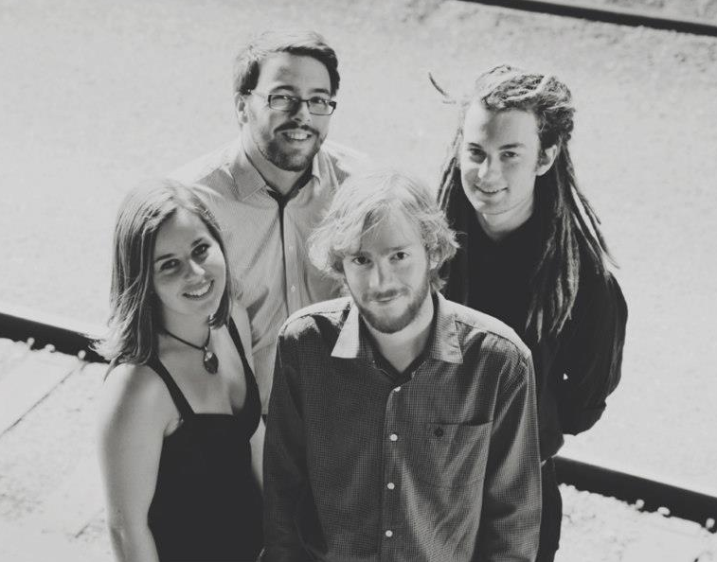
Tolka

What's On:

Music & dancing
Music and Dancing in the street
from 11 till 12pm near the Saturday morning market in Railway Avenue.
Scouts

Two Great Dance Workshops
1:00 to 3:00pm & 3.30 to 5:30pm,
with Norm Ellis (TSDAV). $5 ea.

Kids All Instruments Workshop
For U16s, with Harry and Bill.
1 to 2pm, no charge

Tin Whistle Workshop
Sen Cits, Register here
Community Hall
with Maggie and Bill. 2 to 3pm, $5

Playing Music For Dancing
with Peter Ellis, 1 to 2:30pm, $5

Singing Workshop
with Greg and Dennis.
3 to 4:30pm, $5

Celtic Music Workshop
with Celtic band ‘Tolka’.
3 to 4pm, $5

Playing Session
with Harry. 4 to 5pm, no charge

Family Bush Dance
with Blackberry Jam.
7:30 till 11:00pm, $12/$10/kids free
($2 off if attending a paid w/s)

Register for workshops at the
Senior Citizens Hall, Laurence Gve.
$5 each, or $10 for two or more.

Where:
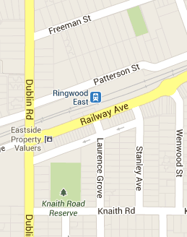

Melway 50 B8

Music and Dancing in the street
Saturday Market, Railway Avenue

Dance & Instrument Workshops
Senior Citizens Hall, Laurence Grove

Music For Dancing & Singing
Scout Hall, Knaith Road Reserve

Family Bush Dance
Senior Citizens Hall, Laurence Grove

Playing Session
Community Hall, Knaith Road Reserve

Registration for Workshops
Senior Citizens Hall, Laurence Grove

