OLD TIME TEA DANCE

Saturday 27th July 2013

 Dance workshop from 2 pm till 4 pm with Peter Ellis 
then afternoon tea
followed by dancing from 4.30 pm till 9.30 pm

Music by
The Gay Charmers

St David’s Uniting Church Hall
74 Melville Rd, Brunswick West
(between Victoria and Hope Sts, Melways 29C6)

Tea & coffee provided
Please bring ‘tea-time goodies’ to share

Tickets: $24 at door
$20 pre-paid

 Ticket includes free admission to afternoon dance workshop

Presented by Folk Victoria &
Traditional Social Dance Association of Victoria

Information: Denise Hibbs 9878-6267, Marion Stabb 9439-7100
Gay Charmers: Stu Simms 5457-9222

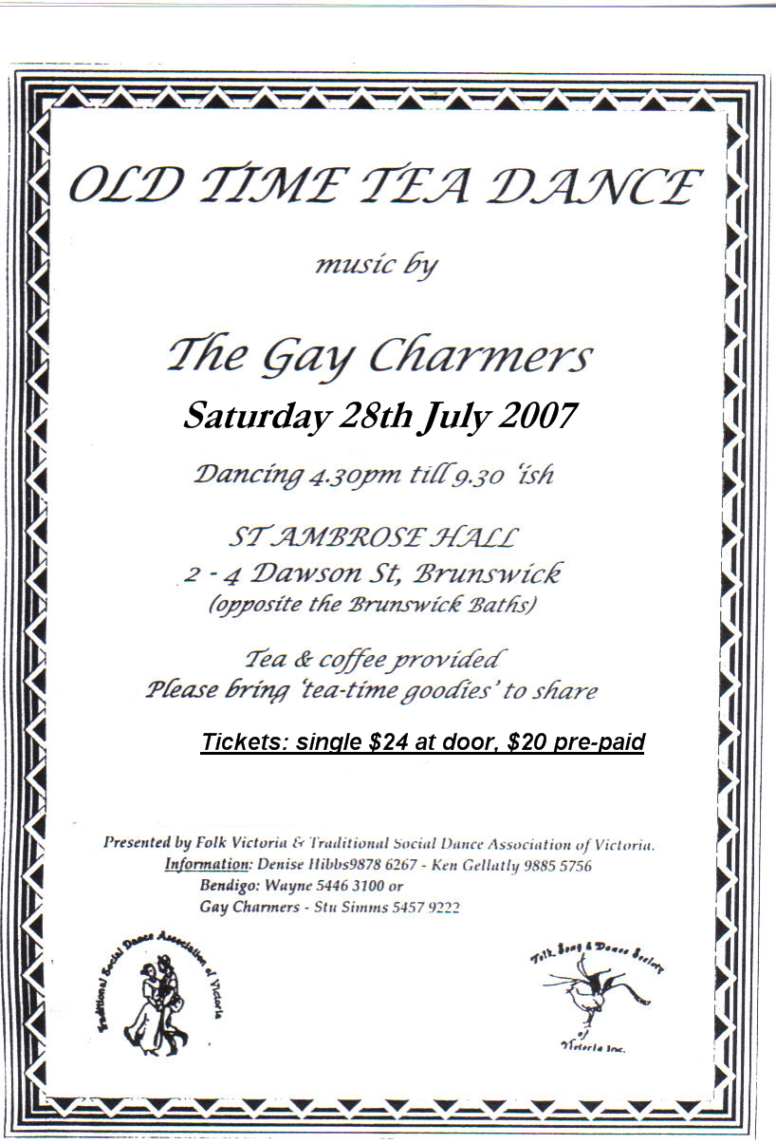

Two Special Dance Workshops
in conjunction with the
Old Time Tea Dance

#1 Sun. 7th July 2-5 pm “Dancing at the 11th Hour”
The TSDAV’s regular dance workshop will be devoted to the
‘Set’ Dances on the Tea Dance program
The Metropolitan Q, Polka Q. & San Toys Q. are easy alternatives
to the more familiar Alberts Q, First Set & Lancers Q,
& the Saraband WC is an interesting variation of the Waltz Cotillion.
Your chance to ‘brush up’ on these Quadrille Sets, And more …
Eleventh Hour Theatre Hall
cnr Gore & Leicester Sts, Fitzroy $4.
. . . . .
#2 Sat. 27th July 2-4 pm - before the “Tea Dance”
an afternoon “Old Time” workshop
with Peter Ellis (Bendigo)
Come and refine your Old Time Technique before the dance.
Peter will also be teaching such delights as Tommy’s Quadrille
& the Swedish Country Dance, along with the Destiny Waltz,
Sparkle Two-Step, & maybe even Garibaldi’s March Waltz.

$5. OR FREE if staying for the Tea Dance
NOTE: same venue as the Tea Dance
St David’s Uniting Church Hall, 74 Melville Rd. Brunswick West

afternoon ‘cup-of-tea- 4 - 4:30 pm
Tea Dance from 4:30 - 9:30 pm
‘Tea Time / Supper ~6:45 pm

enquiries: Norm Ellis (03) 9888 5332
Old Time Tea Dance

Sat. 27th July 2013

at St David’s Uniting Church Hall, 74 Melville Rd. Brunswick West

with music by

The Gay Charmers

MCs Carol Rowe & Robin Simpson, with guest callers

PROGRAMME

1 Circular Waltz (x1) Valeta Waltz (x2)
2 Parma Waltz (x2)
3 Boston Two Step (x2) Evening Three Step (x2)
4 Grand March into The Metropolitan Quadrille (4 figs)

5 Maxina (x2) Modern Waltz (x2)
6 Circle Galop (6x32b) (Sicilian progressive)
7 Sarabande Waltz Cotillion (4x64b)
8 Fox Trot – Monte Carlo (prize)

9 Barn Dance (with prizes) Progressive Jive
10 Charmaine (x2) St Bernard’s Waltz (x2)
11 Polka Quadrille (4x64b)
12 Tangoette (x2) Varsovienna (x2)

‘Tea Time’ (~30 mins)

13 Pride of Erin (x3) (last round in 6/8)
14 San Toys Quadrille (4 figs)
15 Marine 4 Step (x2)

16 Gypsy Tap (x2) Gay Gordons (x2)
17 Chain Double Quadrille (6x48b)
18 Swing Waltz (x3)

19 Highland Schottische (x2) Princess Polka (x2)
20 Guaracha (aka Spanish) Waltz (6x32b) (3 couple longways)
21 “La Flirtation” (5th (last) fig, 1st Set, as big circle)

Auld Lang Syne Advance Australia Fair

