OLD TIME TEA DANCE

Saturday 23rd August 2014
Dancing 4.30 pm till around 9.30 pm

Music by

The Gay Charmers

St David’s Uniting Church Hall
74 Melville Rd, Brunswick West
(between Victoria and Hope Sts, Melways 29C6)

Tea & coffee provided
Please bring tea-time goodies to share

Tickets: $20 at door
$15 pre-paid

Presented by Folk Victoria &
Traditional Social Dance Association of Victoria

Information:
http:// tsdav.vicnet.net.au
Denise Hibbs 9878-6267, Marion Stabb 9439-7100
Bendigo: Carol Rowe 5443-2571
Gay Charmers: Stu Simms 5457-9222
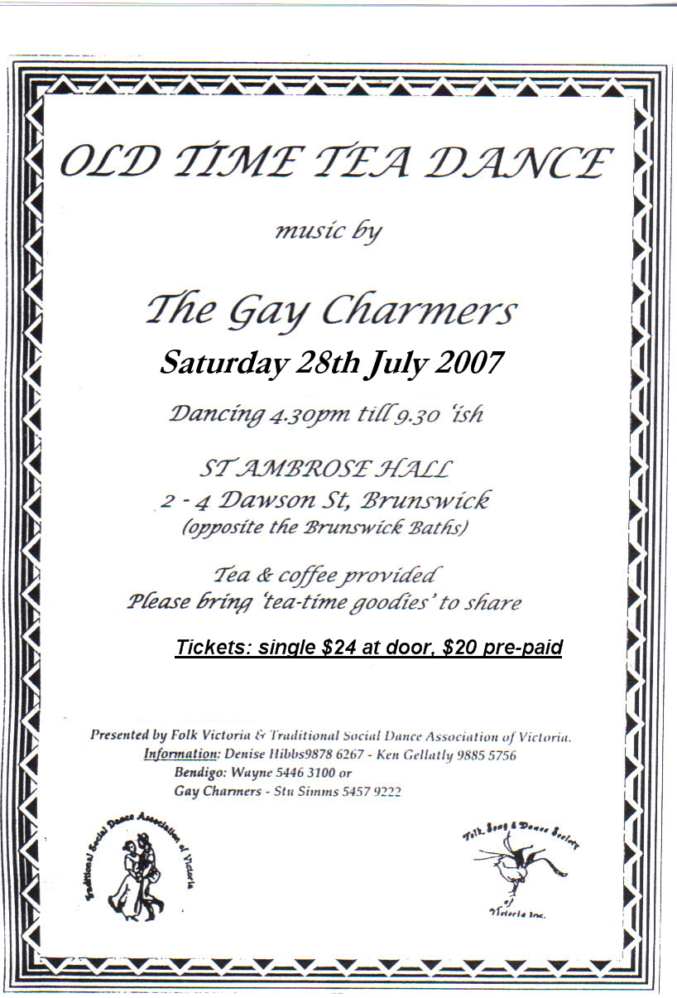

Old Time Tea Dance

Saturday 23rd August 2014

at St David’s Uniting Church Hall, 74 Melville Rd. Brunswick West

with music by

The Gay Charmers

MC: Robin Simpson. With guest callers

PROGRAMME

1 Circular Waltz (x1) Maxina (x2)
2 Parma Waltz (x2)
3 Evening Three Step (x2) Boston Two Step (x2)
4 Grand March into The First Set (of Quadrilles)

5 Modern Waltz (x3)
6 Virginia Reel
7 Waltz Cotillion
8 Fox Trot – Monte Carlo

9 Barn Dance (with prizes) Progressive Jive
10 St Bernard’s Waltz (x2) Waltz Oxford (x2)
11 Eightsome Reel
12 Polka Medley: Varsovienna / Mazurka / Plain Polka

‘Tea Time’ (~30 mins)

13 Gypsy Tap (x2) Gay Gordons (x2)
14 Pride of Erin (x3) (last round in 6/8)
15 The Alberts Quadrille (with 6th fig. in Polka time)

16 Highland Schottische (x2)
17 Swing Waltz (x3)
18 The Lancers Quadrille

19 Tangoette (x2)
20 Charmaine (x3)
21 Waltz Country Dance (40 bar tunes)

Auld Lang Syne Advance Australia Fair

