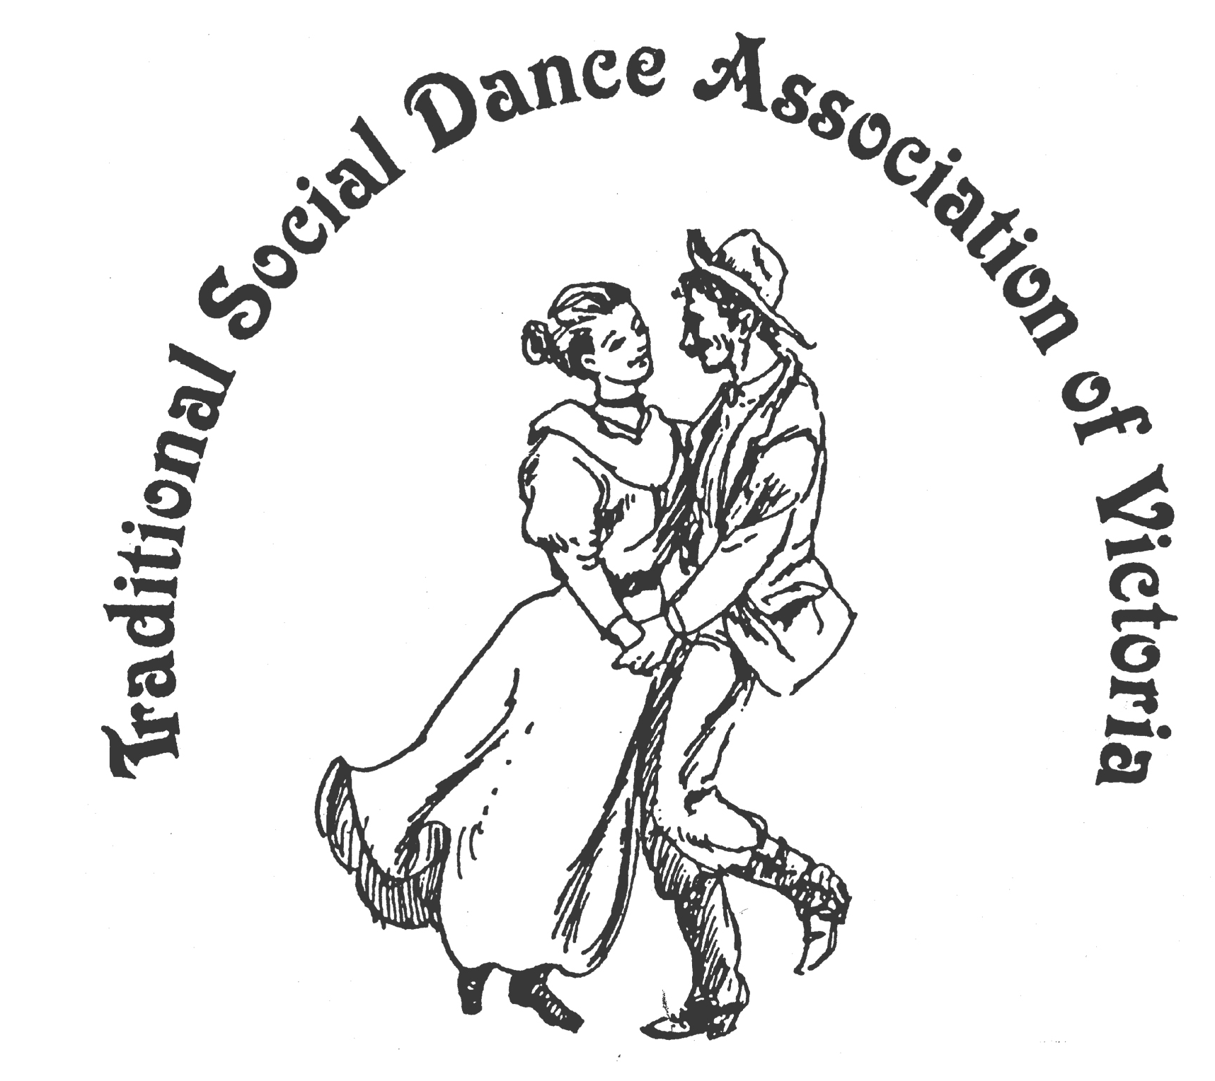
TSDAV’s SPRING DANCE WEEKEND
7th - 9th November 2014
Foreshore Community Hall, Portarlington
Celebrating 20 Years at Portarlington
1.5 hrs drive SW of Melbourne, past Geelong, Melways 239 F2

Evening Dances on Friday and Saturday
Dance Workshops
Contra Dances with Julie Bishop (Sydney)
Scottish Country Dance and Scottish dance music workshops with Matt Robertson (Melb)
Nordic Dances with Roger Gifford (Canberra)
Roaring Twenties in OZ with Peter Ellis (Bendigo)

Saturday Evening Dance with musicians:
Matt Robertson, Duncan Smith and Julia Arnold

*** fun, laughter, good dancing ***
*** good times, good friends ***
NOT TO BE MISSED

For Information - http://tsdav.vicnet.net.au
Marion Stabb - (03) 9439 7100
George Ansell - (03) 9890 5650

