**TSDAV Spring Dance Weekend 2024 Ticket Prices**

|  |  |
| --- | --- |
| **Weekend Ticket** | $95 |
| **Saturday all day and evening** | $70 |
| **Saturday evening dance only** | $20 |
| **Single session only** | $15 |

**✂- - - - - - - - - - - - - - - - - - - - - - - - - - - - - - - - - - - - - - - - - - - - - - - - - - - - - - - - - - - - - - - - - - - - -**

**APPLICATION FORM**

**I/we would like tickets for the TSDAV 2024 Spring Dance Weekend**

***If more than one applicant, please list all names/addresses***

**Name(s): . . . . . . . . . . . . . . . . . . . . . . . . . . . . . . . . . . . . . . . . . . . . . . . . . . . . . . . . . .**

**Address: . . . . . . . . . . . . . . . . . . . . . . . . . . . . . . . . . . . . . . . . . . . . . . . . . . . . . . . . . .**

**Email: . . . . . . . . . . . . . . . . . . . . . . . . . . . . . . . . . . . . . . . .** **Tel: . . . . . . . . . . . . . . . . .**

**Any special dietary requirements (*or none*): . . . . . . . . . . . . . . . . . . . . . . . . . . . . .**

**Number *of tickets required* Total**

 

**___**x **Weekend tickets @ $95** $ ____

**OR**

**___**x **Saturday all-day tickets @ $70** $ ____

***TSDAV membership per registration is included in above***

**___**x **Saturday night dance only @ $20** $ ____

**___**x **Single session @ $15** $ ____

**Total : $ ____**

** ** When booking we need the information on this form!

**NB - No payment accepted without a fully completed application form.**

EFT can be accepted to BSB 633 000 Account 219 371 150

BUT **MUST BE ACCOMPANIED** by your name in the reference field

AND email this form to:

[george.ansell@bigpond.com](mailto:george.ansell@bigpond.com)

Cash or cheques made out to TSDAV, with this completed form, to be sent to:

***George Ansell, TSDAV, 62 Wellman St. Box Hill South, VIC 3128***

***or any TSDAV committee member***

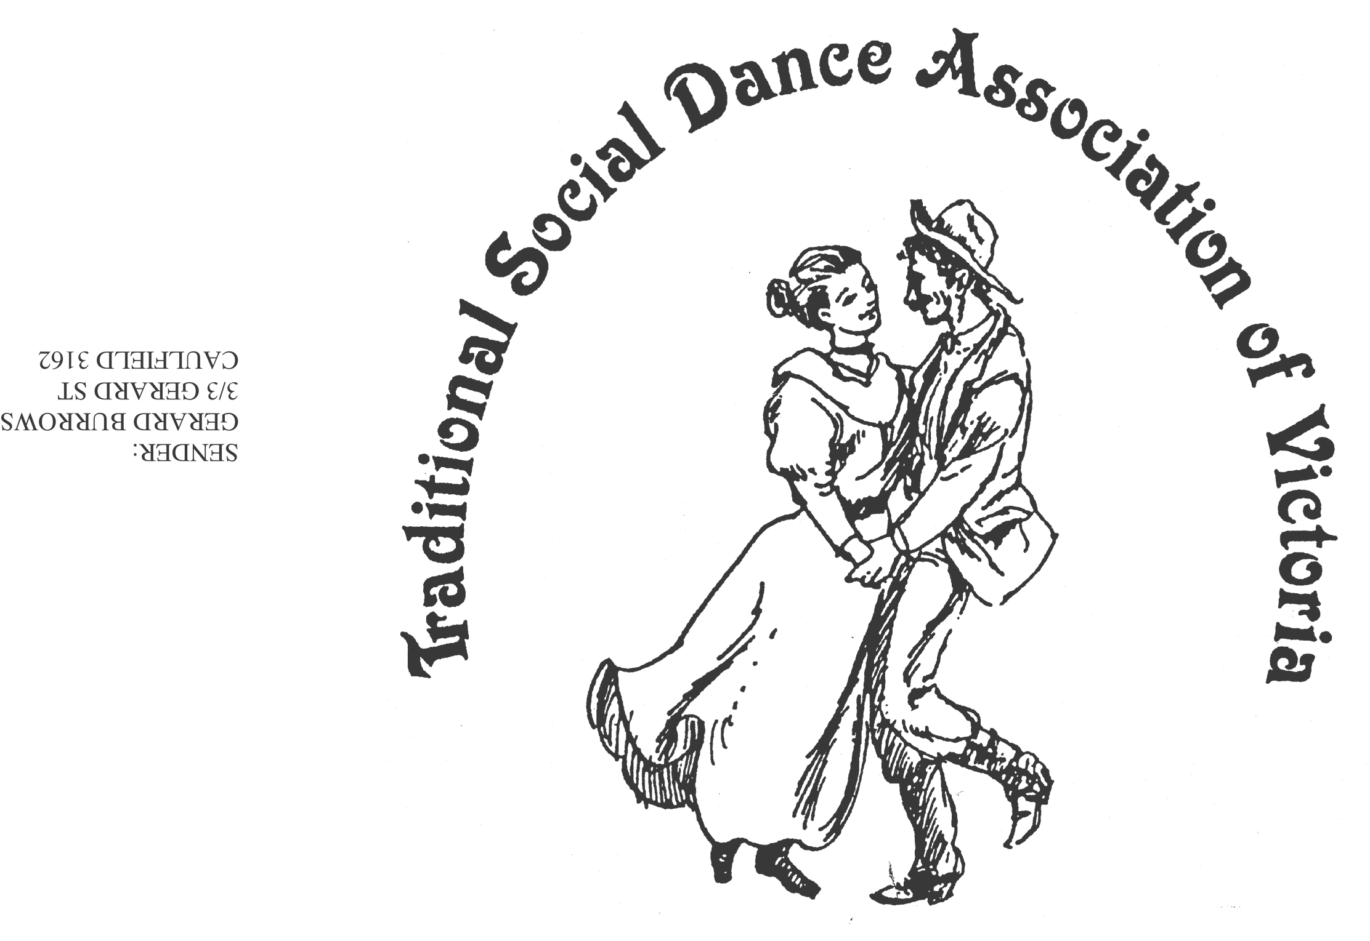Spring Dance Weekend

**8th–10th November 2024**

**PARKS HALL COMMUNITY CENTRE**

**Portarlington**

(1.5 hrs drive SW of Melbourne, 20 minutes past Geelong. Or catch the ferry)

A Touch of Pearl!

Celebrate 30 years at Portarlington

Dance workshops: Sheree Hill (English & Contra), Norm Ellis (Australian),

Anne Archdeacon (Modern English), Vasilios Tsalkos (Greek),

Kim South (Scottish)

*PLUS, two evenings of social dancing*

***Dance Programme***

Friday Evening: **Welcome Dance** and Registration with drinks and nibbles

Saturday Night: Celebrate 30 years with a **Dance Social** *~ with guest musicians*

Sunday Afternoon: Wind down with a **Farewell Dance**

***Workshop Programme***

Saturday/Sunday: 6 dance workshops, 1 dance music session

***For Information****: Norm Ellis 03 9888 5332*

*or George Ansell 03 9890 5650 or Judith Baillie 0431 188 026*

*NB - you will need to organise your own accommodation for the weekend.*

**Website:** [**http://tsdav.asn.au/events**](http://tsdav.asn.au/events)

## Programme for the Weekend

|  |  |  |  |  |
| --- | --- | --- | --- | --- |
| **Day** | **Event** | **Performer, Musician** & **Topic** | | |
| **Friday night** | ***Registration***  from 7.30 pm | *with drinks and nibbles* | | |
|  | ***Welcome Dance***  from 8.00 pm | **Informal night of simple social dancing**  with guest callers | | |
| **Saturday** | ***Registration***  from 9.00am | *at the Hall* | | |
|  | ***Dance Workshop***  9.15 – 10.45 | **“English Dance”** | | **Sheree Hill**  (Brisbane) |
|  | ***Dance Workshop***  11.00 – 12.30 | **“Scottish Country”** | | **Kim South**  (Geelong) |
|  | ***Dance Workshop***  1.45 – 3.15 | **“Greek Dance”** | | **Vasilios Tsalkos**  (Melbourne) |
|  | ***Dance Workshop***  3.30 – 5.00 | **“Tribute to Lucy Stockdale”** | | **Norm Ellis**  (Melbourne) |
| **Saturday night** | ***Evening Dance***  from 8.00 pm |  | **“A Touch of Pearl!” Social**  ***- with music from Denise Robert et al*** | |
| **Sunday** | ***Dance Workshop***  9.45 – 11.15 | **“Contra”** | | **Sheree Hill**  (Brisbane) |
|  | ***Dance Workshop***  11.30 – 1.00 | **“Modern English”** | | **Anne Archdeacon**  (Melbourne) |
|  | ***Farewell Dance***  2.00 – 3.30 | **“Closing Dance”** | | **Norm Ellis**  (Melbourne) |
|  | ***Weekend Finale***  3.30 | **Farewell**  **Afternoon Tea** | |  |

**Food Arrangements**

**All morning & afternoon teas:** Provided by the TSDAV

**Lunches:** BYO, or from the local bakeries

**Saturday evening:** Light supper provided during evening dance

Cafes, restaurants, hotels, etc. are available in town.

**accommodation:** *you will need to organise your own accommodation for the weekend.*

**OUR PRESENTERS**

**ANNE ARCHDEACON** has danced all her life in some form or another, introduced to Scottish Country Dancing through local bush dances in Far North Queensland and eventually taking exams to become a qualified Scottish country dance teacher. Living 2000 km away from the nearest RSCDS branch, she did a lot of travelling to learn and to dance with other experienced people. As part of that travel she went to Pinewoods, south of Boston USA, and in an afternoon class at SCD camp rediscovered English Country Dance. Enjoying the more relaxed style and learning and dancing more, particularly in the USA and then in UK, she appreciated the immense variety of style, dance length, phrasing and wonderful music (which is always a huge part of dance camps). Anne taught ECD in Cairns and on the Atherton tablelands and since coming to Melbourne in 2001, has been teaching a U3A class and getting the occasional 'gig' with TSDAV. She loves teaching people to dance and hopes they get as much joy and satisfaction out of it as she does.

**KIM SOUTH** was brought up with a deep love of her Scottish ancestry and began Highland Dancing at the age of 10. This led to Scottish Country Dancing as a teenager. She has been dancing for over thirty years and teaching in Geelong and surrounds for about twenty of those years. She nominates as one of the highlights of her dancing life the opportunity to visit Scotland and dance to the abundance of live music there.

**NORM ELLIS** was along with Shirley Andrews and Bruce McClure, a founding member of the TSDAV, and instigator of the Dance Composers’ Competition. A keen dancer, caller and dance teacher of many years standing, Norm will present a selection of her dances as a tribute to Lucy Stockdale, and send us off with a Farewell Dance.

**SHEREE HILL** fell in love with folk dancing at the age of 5 after learning dances and performing them at her school’s fancy dress ball. For the last 30 years she has been sharing that love of dance by running a community group in Brisbane, Dance Kaleidoscope, teaching both beginners and experienced dancers. She also teaches a performance group and holds dances for the general public. Her favourite styles are English and Contra.

**VASILIOS TSALKOZ** discovered his passion for dance at just 3 years old, tagging along with his older brother to dance classes. Since then, dance has been his source of joy. In 2018, Vasilios began sharing his extensive dance experience by teaching others. His students have ranged from children as young as 5 to seniors approaching their 90s, each bringing a unique energy and enthusiasm to his classes. Vasilios has had the opportunity to teach at prominent cultural institutions within the Melbourne Greek community, including The Hellenic Cultural Association of Melbourne, The Greek Women of Northern Suburbs, the Greek Community of Melbourne Language Schools, and The Greek Women Traditional Dancing Group “The Arhontisses”. For Vasilios, dance is more than just movement—it's a connection to heritage and community. Whether he's teaching, performing, or choreographing, Vasilios aims to share the cultural richness and joy of dance with everyone he meets.

**Our DANCE MUSICIANS: Robert Stephens** is a long-time veteran of the Sydney, Canberra and Melbourne music scenes, performing with piano, accordion, guitar and vocals. He has been a lead musician in the Melbourne Colonial Dancers Band for the past 15 years. **Maggie Duncan** is a very experienced fiddle player and music teacher who has played in many bush bands, as well as in contra and old-time bands. **Lisa Christensen** is a former fiddle player with the Melbourne Scottish Fiddle Club and on the music CD Growling Dogs (Australian Fiddle Tunes) produced by Greg O’Leary in 2002. **Denise Hibbs** is known through her long involvement with Melbourne Colonial Dancers. She is a dancer and fiddle player and has been leader of the MCD band for 20 years. **Richard Ayling** plays mandolin in the MCD band and is an administrator of australianfolkmusic.com.au, where you can view several volumes of dance music researched and produced in collaboration with Denise. All band members are particularly passionate about the preservation and playing of early Australian collected dance tunes and play for regular dances and balls in Melbourne, and for dance events at various festivals, including the National Folk Festival in Canberra and Bundanoon DanceFest in NSW.