TSDAV Spring Dance Weekend 2023 Ticket Prices
Weekend Ticket | $90
Saturday all day and evening | $70
Saturday evening dance only | $20

- - - - - - - - - - - - - - - - - - - - - - - - - - - - - - - - - - - - - - - - - - - - - - - - - - - - - - - - - - - - - - - - - - - - -
APPLICATION FORM

I/we would like tickets for the TSDAV 2023 Spring Dance Weekend
If more than one applicant, please list all names/addresses

Name(s): . . . . . . . . . . . . . . . . . . . . . . . . . . . . . . . . . . . . . . . . . . . . . . . . . . . . . . . . . .

Address: . . . . . . . . . . . . . . . . . . . . . . . . . . . . . . . . . . . . . . . . . . . . . . . . . . . . . . . . . .

Email: . . . . . . . . . . . . . . . . . . . . . . . . . . . . . . . . . . . . . . . . Tel: . . . . . . . . . . . . . . . . .

Any special dietary requirements (or none): . . . . . . . . . . . . . . . . . . . . . . . . . . . . .

Number required Total
 
___x Weekend tickets @ $90 $ ____
___x Saturday all-day tickets @ $70 $ ____
TSDAV membership per registration is included
___x Saturday night dance only @ $20 $ ____

Total : $ ____

  When booking we need the information on this form!
NB - No payment accepted without a fully completed application form.

EFT can be accepted to BSB 013375 Account 311825659
BUT MUST BE ACCOMPANIED by your name in the reference field
AND email this form to:
george.ansell@bigpond.com

Cash or cheques made out to TSDAV, with this completed form, to be sent to:

George Ansell, TSDAV, 62 Wellman St. Box Hill South, VIC 3128
or any TSDAV committee member
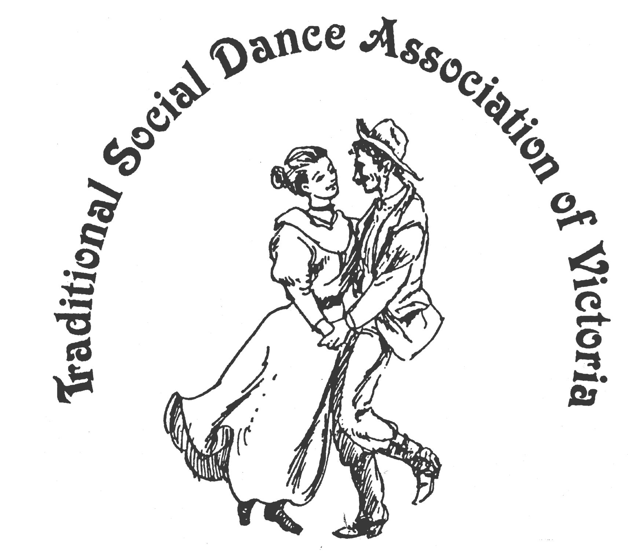
Spring Dance Weekend

17th–19th November 2023

PARKS HALL COMMUNITY CENTRE
Portarlington
(1.5 hrs drive SW of Melbourne, 20 minutes past Geelong. Or catch the ferry)

A Kaleidoscope of dance!
Come in a Kaleidoscope of Colours

Dance workshops: Don Richmond, Arthur Kingsland
Joanne Thompson, Duncan Smith
And two evenings of social dancing

Dance Programme
Friday Evening: Welcome Dance and Registration with drinks and nibbles
Saturday Night: Celebrate the season with a Dance Social ~ with guest musicians
Sunday Afternoon: Wind down with a Farewell Dance

Workshop Programme
Saturday/Sunday: 6 dance workshops, 1 dance music session

For Information: Norm Ellis 03 9888 5332
or George Ansell 03 9890 5650
or Judith Baillie 0431 188 026

Website: http://tsdav.asn.au/events

Programme for the Weekend
Day | Event | Performer, Musician & Topic
Friday night | Registration  from 7.30 pm | with drinks and nibbles
 | Welcome Dance  from 8.00 pm | Informal night of simple social dancing  with guest callers
Saturday | Registration  from 9.00am | at the Hall
 | Dance Workshop  9.15 – 10.45 | “Tribute to Mike Waters” |  | Don Richmond  (Sydney)
 | Dance Workshop  11.00 – 12.30 | “International” |  | Joanne Thompson  (Victoria)
 | Dance Workshop  1.45 – 3.15 | “Celtic Eclectic Challenges” |  | Arthur Kingsland  (Newcastle)
 | Dance Workshop  3.30 – 5.00 | “Waltzing in Chains” |  | Don Richmond  (Sydney)
Saturday night | Evening Dance  from 8.00 pm |  | “Dancing Around the World!” Social  - with music from Denise Robert et al
Sunday | Dance Workshop  9.45 – 11.15 | “English Country Theme” |  | Arthur Kingsland  (Newcastle)
 | Dance Workshop  11.30 – 1.00 | “New England Contra” |  | Duncan Smith  (Victoria)
 | Farewell Dance  2.00 – 3.30 | Final session, incl. requests from the workshops |  | Norm Ellis  (Melbourne)
 | Weekend Finale  3.30 | Farewell  Afternoon Tea

Food Arrangements
All morning & afternoon teas: Provided by the TSDAV
Lunches: BYO, or from the local bakeries
Saturday evening: Light supper provided during evening dance
Cafes, restaurants, hotels, etc. are available in town.
accommodation: Ring local contacts or check the TSDAV website.
OUR PRESENTERS

ARTHUR KINGSLAND is known for teaching interesting variations and challenging dances from a range of Celtic traditions, and also for writing challenging dances. He has been teaching dancing for many years covering Celtic traditions including Australian Contemporary and Colonial, Irish Set dancing, English Country, Scottish Country and American Contra dancing, and he has organised the Dancers’ Dance and a number of workshops at the National Folk Festival on several occasions, presenting challenging dances. Arthur, with his partner Julia, taught the weekly Newcastle Irish Set Dance class for over 20 years.

DON RICHMOND has presented workshops at festivals and dance weekends, and called at many dances and balls. He is a Life Member of the Bush Music Club and has been the Principal Caller for many of their annual Heritage Balls. Don is no stranger to the TSDAV and for many years has been a presenter at our annual Dance Competition. In his fifth visit to Portarlington Don has chosen to acknowledge the creative dance genius of Sydney caller and dance composer Mike Waters in the workshop ‘Tribute to Mike Waters’.
Mike was a Sydney based caller and long term supporter of bush-dancing in the Bush Music Club. Mike also ran a weekly bush dance group in Sutherland for over twenty years and wrote many dances, with some using his own tunes. Don will also present a workshop ‘Waltzing in Chains’, featuring dances with differing versions of chain movements, including dances written by Mike Waters.

DUNCAN SMITH grew up in Boston, USA in a dancing family. His father Alan Smith was a well known square dance caller, having learned from Ralph Page, the "dean of New England square and contra dance callers" in the 1940s. Duncan began dancing regularly in 1960, mainly in the Scottish tradition, and picked up English Country, Morris, and Sword while working several summers as part of the maintenance crew at Pinewoods Camp. An RSCDS certified teacher since 1976, and dance musician since 1980, Duncan has taught and/or played at classes, weekends and workshops in the USA, Canada, England, Scotland, Germany, Japan, New Zealand, and Australia.

JO THOMPSON has been dancing International Folk Dancing for over 20 years. She has been teaching International Folk Dancing since she moved to Castlemaine in 2015. Jo also teaches English Country dancing. She has been fortunate to be the caller for dances with live music provided by the “Band Without Borders (aka KGB – Klezmer, Gypsy, Balkan)” led by Andy Rigby. Jo holds a Recreational Folk Dance Teaching Certificate from Folk Dance Australia. Her greatest reward is to bring the joy of dancing to others.

Our DANCE MUSICIANS:
Robert Stephens is a long-time veteran of the Sydney, Canberra and Melbourne music scenes, performing with piano, accordion, guitar and vocals. He has been a lead musician in the Melbourne Colonial Dancers Band for the past 15 years.
Maggie Duncan is a very experienced fiddle player and music teacher who has played in many bush bands, as well as in contra and old-time bands.
Lisa Christensen is a former fiddle player with the Melbourne Scottish Fiddle Club and on the music CD Growling Dogs (Australian Fiddle Tunes) produced by Greg O’Leary in 2002.
Denise Hibbs is known through her long involvement with Melbourne Colonial Dancers. She is a dancer and fiddle player and has been leader of the MCD band for 20 years.
Richard Ayling plays mandolin in the MCD band and is an administrator of australianfolkmusic.com.au, where you can view several volumes of dance music researched and produced in collaboration with Denise.

All band members are particularly passionate about the preservation and playing of early Australian collected dance tunes and play for regular dances and balls in Melbourne, and for dance events at various festivals, including the National Folk Festival in Canberra and Bundanoon DanceFest in NSW.

~ ~ ~

