TSDAV Spring Dance Weekend 2019 Ticket Prices
Weekend Ticket  TSDAV members | $80
Weekend Ticket  Non-members | $90
Sat all day and evening | $65
Sat evening dance only | $15
Single workshop | $15

Are you a member? Join now and get tickets at member’s rates
- - - - - - - - - - - - - - - - - - - - - - - - - - - - - - - - - - - - - - - - - - - - - - - - - - - - - - - - - - - - - - - - - - - - -
APPLICATION FORM

I/we would like tickets for the TSDAV 2019 Spring Dance Weekend
If more than one applicant, please list all names/addresses

Name(s): . . . . . . . . . . . . . . . . . . . . . . . . . . . . . . . . . . . . . . . . . Tel: . . . . . . . . . . . .

Address: . . . . . . . . . . . . . . . . . . . . . . . . . . . . . . . . . . . . . . . . . . . . . . . . . . . . . . . . . . .

Email: . . . . . . . . . . . . . . . . . . . . . . . . . . . . . . . . . . . . . . . . . . . . . . . . . . . . . . . . . . . . .

Any special dietary requirements (or none): . . . . . . . . . . . . . . . . . . . . . . . . . . . . . . .

Number required Total
 
___x TSDAV member weekend tickets @ $80 $ ____
___x Non-member weekend tickets @ $90 $ ____
___x Saturday all-day tickets @ $65 $ ____
___x Saturday night dance only @ $15 $ ____
___x Single workshop @ $15 $ ____
___x TSDAV memberships - family @ $33 $ ____
- single @ $22 $ ____
Interstate: single/couple @ $15 $ ____

Total : $ ____

  When booking we need the information on this form!
NB - No payment accepted without a fully completed application form.
Cash or cheques made out to TSDAV, with this completed form, to be sent to:

The treasurer, TSDAV, or any TSDAV committee member
Email: info.tsdav@gmail.com
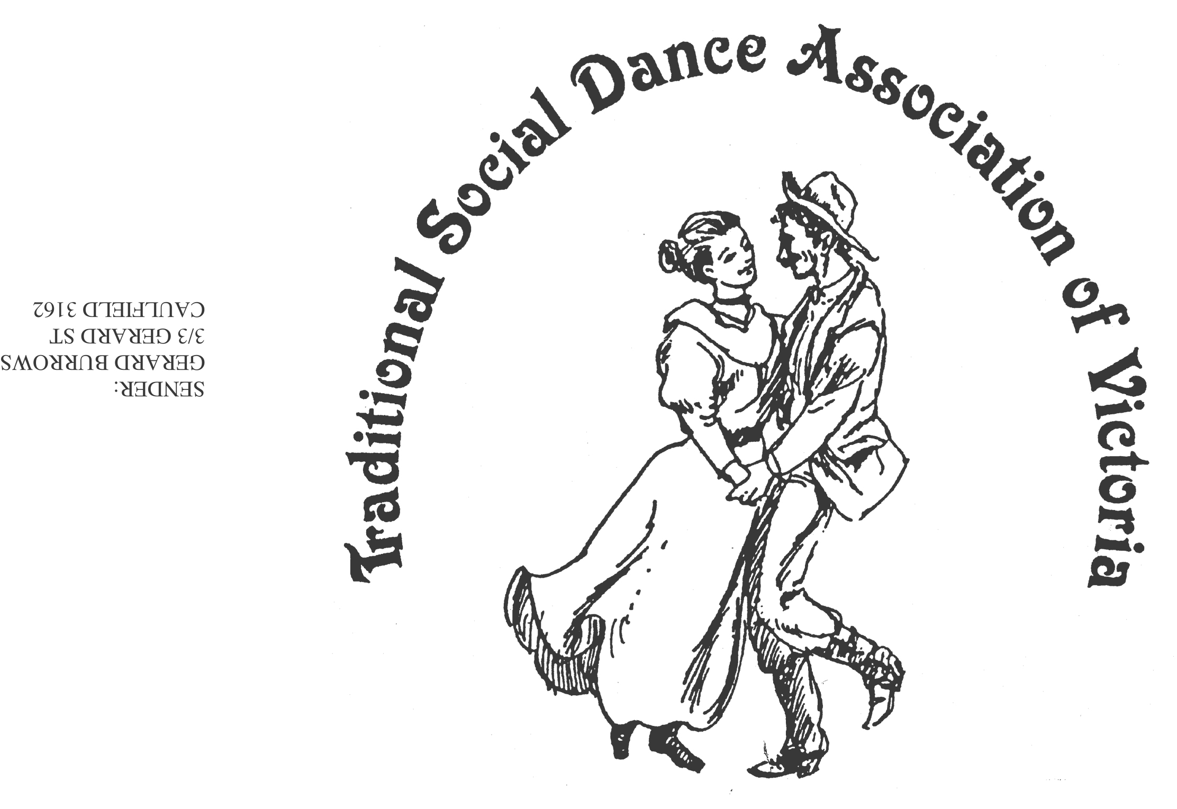
Spring Dance Weekend

8th –10th November 2019

PARKS HALL COMMUNITY CENTRE
Portarlington
(1.5 hrs drive SW of Melbourne, 20 minutes past Geelong. Or catch the ferry. MelwayP.239 F2)

A whole weekend of dance workshops & evening dances !
“Dancing Around the World !”
- at the Village by the Sea !
# Don Richmond – “Ladies in Chains” # Keith Wood – “Unusual Contras”
# Kim South – “A Scotch Selection” # Leanne Stute – “Ballroom for Bushies”
# Luba Baksheev – “Russian Folk Dance” # George Ansell – “Evolving Reels”
# Norm Ellis – A surprise ‘DfD’ selection # and a Dance Music Workshop !

Dance Programme
Friday Evening: Welcome Dance and Registration with drinks and nibbles
Saturday Night: Celebrate the season with a Dance Social ~ with guest musicians
Sunday Afternoon: Wind down with a Farewell Dance

Workshop Programme
Saturday/Sunday: 6 dance workshops, 1 dance music session

For Information: Norm Ellis 03 9888 5332
or George Ansell 03 9890 5650
or Judith Baillie 0431 188 026

Website: http://tsdav.asn.au/events

