**TSDAV Spring Dance Weekend 2025 Ticket Prices**

|  |  |
| --- | --- |
| **Weekend Ticket** | $95 |
| **Saturday all day and evening** | $70 |
| **Saturday evening dance only** | $20 |
| **Single session only** | $15 |

**✂- - - - - - - - - - - - - - - - - - - - - - - - - - - - - - - - - - - - - - - - - - - - - - - - - - - - - - - - - - - - - - - - - - - - -**

**APPLICATION FORM**

**I/we would like tickets for the TSDAV 2025 Spring Dance Weekend**

*If more than one applicant, please list all names/addresses*

**Name(s): . . . . . . . . . . . . . . . . . . . . . . . . . . . . . . . . . . . . . . . . . . . . . . . . . . . . . . . . . .**

**Address: . . . . . . . . . . . . . . . . . . . . . . . . . . . . . . . . . . . . . . . . . . . . . . . . . . . . . . . . . .**

**Email: . . . . . . . . . . . . . . . . . . . . . . . . . . . . . . . . . . . . . . . .** **Tel: . . . . . . . . . . . . . . . . .**

**Emergency contact: . . . . . . . . . . . . . . . . . . . . . . . . . . . .**  **Tel: . . . . . . . . . . . . . . . . .**

**Any special dietary requirements (or none): . . . . . . . . . . . . . . . . . . . . . . . . . . . . .**

**Number required Total**

 

**___**x **Weekend tickets @ $95** $ ____

**___**x **Saturday all-day tickets @ $70** $ ____

**TSDAV membership per registration included in above**

**___**x **Saturday night dance only @ $20** $ ____

**___**x **Single session @ $15** $ ____

**Total : $ ____**

** ** When booking we need the information on this form!

**NB - No payment accepted without a fully completed application form.**

EFT can be accepted to: BSB 633-000 Account 219 371 150

BUT **MUST BE ACCOMPANIED** by your name in the reference field

AND email this form to:

[george.ansell@bigpond.com](mailto:george.ansell@bigpond.com)

Cash or cheques made out to TSDAV, with this completed form, to be sent to:

***George Ansell, TSDAV, 62 Wellman St. Box Hill South, VIC 3128***

***or any TSDAV committee member***

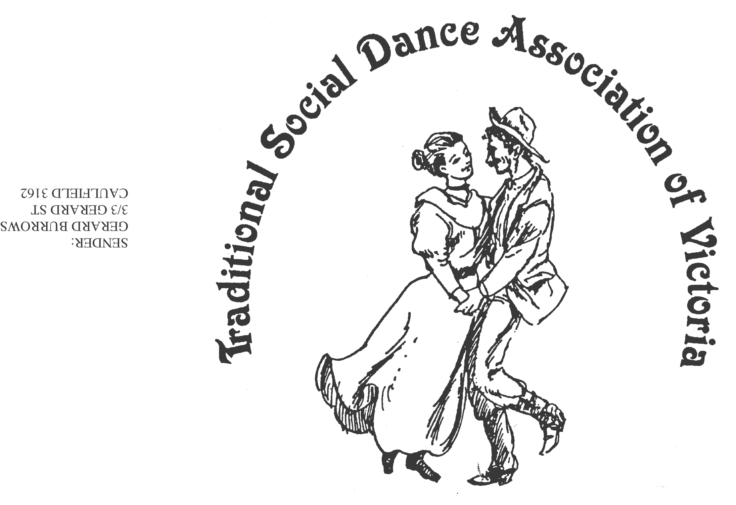Spring Dance Weekend

**7th–9th November 2025**

**PARKS HALL COMMUNITY CENTRE**

**Portarlington**

(1.5 hrs drive SW of Melbourne, 20 minutes past Geelong. Or catch the ferry)

Come Dressed as a Dance

Dance workshops: Keith Wood (Australian & Contra), Ian Kendall (Welsh),

Roger Gifford (Scandinavian), Darren Taylor (Square Dancing),

Jane Bullock/George Ansell (English)

*PLUS, two evenings of social dancing*

***Dance Programme***

Friday Evening: **Welcome Dance** and Registration with drinks and nibbles

Saturday Night: **Dance Social** (themed if you wish)*~ with guest musicians*

Sunday Afternoon: Wind down with a **Farewell Dance**

***Workshop Programme***

Saturday/Sunday: 6 dance workshops, 1 dance music session

***For Information****: Norm Ellis 03 9888 5332*

*or George Ansell 03 9890 5650*

*or Judith Baillie 0431 188 026*

**Website:** [**http://tsdav.asn.au/events**](http://tsdav.asn.au/events)

## Programme for the Weekend

|  |  |  |  |  |
| --- | --- | --- | --- | --- |
| **Day** | **Event** | **Performer, Musician** & **Topic** | | |
| **Friday night** | ***Registration***  from 7.30 pm | *with drinks and nibbles* | | |
|  | ***Welcome Dance***  from 8.00 pm | **Informal night of simple social dancing**  with guest callers | | |
| **Saturday** | ***Registration***  from 9.00am | *at the Hall* | | |
|  | ***Dance Workshop***  9.30 – 10.45 | **“Modern Australian”** | | **Keith Wood**  (Sydney) |
|  | ***Dance Workshop***  11.30 – 1.00 | **“Welsh Country Dances”** | | **Ian Kendall**  (Melbourne) |
|  | ***Dance Workshop***  1.45 – 3.15 | **“Diverse Nordic Folk Dances”** | | **Roger Gifford**  (Canberra) |
|  | ***Dance Workshop***  3.30 – 5.00 | **“Square Dancing”** | | **Darren Taylor**  (Geelong) |
| **Saturday night** | ***Evening Dance***  from 8.00 pm |  | **“Come Dressed as a Dance” Social**  ***- with music from Denise, Robert et al - MC Norm Ellis*** | |
| **Sunday** | ***Dance Workshop***  9.45 – 11.15 | **“Ancient & Modern English”** | | **Jane & George**  (Melbourne) |
|  | ***Dance Workshop***  11.30 – 1.00 | **“Contra”** | | **Keith Wood**  (Sydney) |
|  | ***Farewell Dance***  2.00 – 3.30 | **“Closing Dance”** | | **Norm Ellis**  (Melbourne) |
|  | ***Weekend Finale***  3.30 | **Farewell**  **Afternoon Tea** | |  |

**Food Arrangements**

**All morning & afternoon teas:** Provided by the TSDAV

**Lunches:** BYO, or from the local bakeries

**Saturday evening:** Light supper provided during evening dance

Cafes, restaurants, hotels, etc. are available in town.

**accommodation:** *you will need to organise your own accommodation for the weekend.*