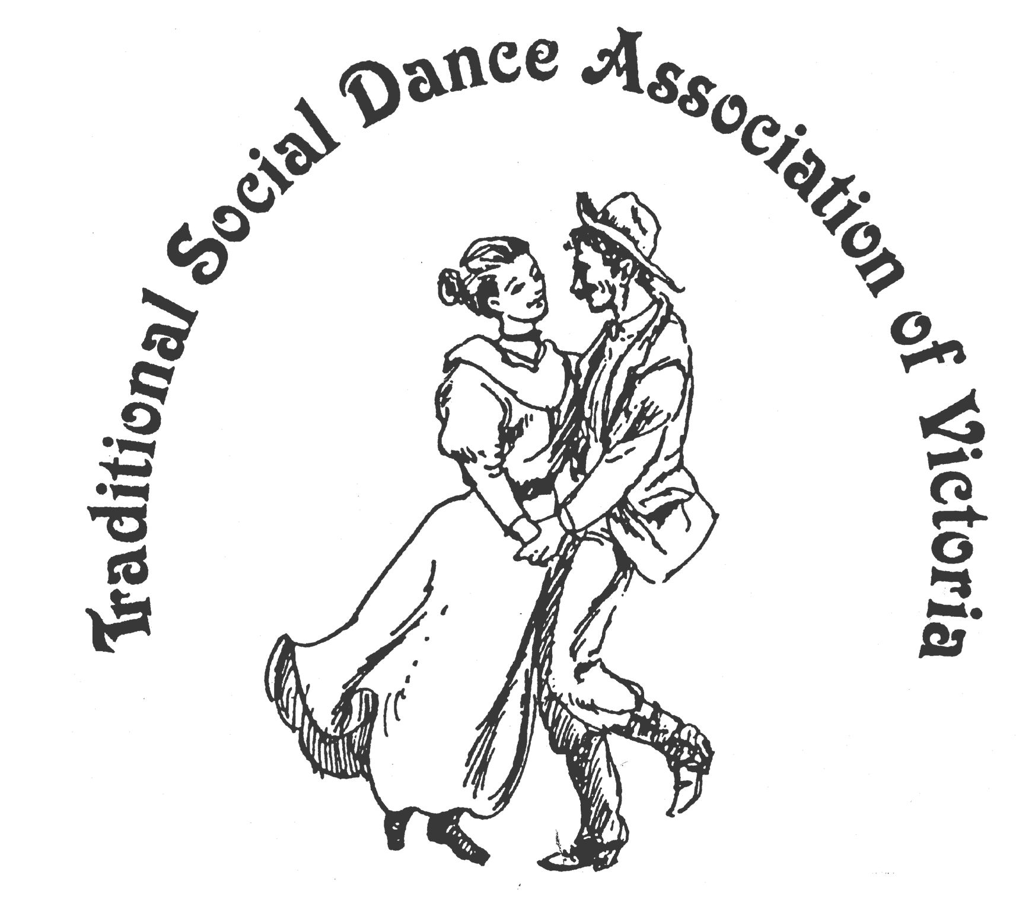
Spring Dance Weekend

10th – 12th November 2017

PARKS HALL COMMUNITY CENTRE
Portarlington
(1.5 hrs drive SW of Melbourne, 20 mins past Geelong. Melways 239 F2)

Dancing at the Village by the Sea !
“In REMEMBRANCE of
Times and Traditions Past”
~ Jane Austen ~ Pat Shaw ~ Peter Ellis ~ ‘Our Ned’ ~

Dance Programme
Friday Evening: Welcome Dance and Registration with drinks and nibbles
Saturday Night: the Big REMEMBRANCE Day Social
celebrating “Times and Traditions Past” ~ with guest musicians.

Workshop Programme
Saturday/Sunday: 6 dance workshops, 1 dance music workshop
plus a mini New Dance Competition.

For Information: Norm Ellis 03-9888 5332
George Ansell 03-9890-5650 or Judith Baillie 03-9544-4241

Website: http://tsdav.asn.au/events

Supported by bellarine bayside

Programme for the Weekend
Day | Event | Performer, Musician & Topic
Friday night | Registration  from 7.30 pm | with drinks and nibbles
 | Welcome Dance  from 8.00 pm | Informal night of dancing  with guest callers
Saturday | Registration  from 9.00 am | at the Hall
 | Dance Workshop  9.15 – 10.45 | “Celebration Dances  for Remembrance Day” |  | Norm Ellis  (Melbourne)
 | Dance Workshop  11.00 – 12.30 | “A Pat Shaw Selection” |  | George Ansell  (Melbourne)
 | Dance Workshop  1.45 – 3.15 | "Celebrating Jane" |  | Sheree Greenhill  (Brisbane)
 | Music Workshop  Bayview Room  1.45 – 3.15 | Playing Traditional  Australian Dance Music |  | Alan Musgrove  & Robert Stephens (Melbourne)
 | Dance Workshop  3.30 – 5.00 | “Ninety Degrees of Traditional Dance” |  | Don Richmond  (Sydney)
Saturday night | Evening Dance  from 8.00 pm |  | The “Remembrance Day” Social  - with music from Denise Robert Alan & Jean et al
Sunday | Dance Workshop  9.45 – 11.15 | Modern English Dances  “these are a few of my favourite things” |  | Maureen Morris  & Merilyn Taylor  (Adelaide)
 | Dance Workshop  11.30 – 1.00 | "Quirky Contras" |  | Sheree Greenhill  (Brisbane)
 | Weekend Finale  2.00 – 3.30 | our very own:  “New Dance”  Competition |  | followed by -  Farewell  Afternoon Tea

Food Arrangements
All morning & afternoon teas: Provided by the TSDAV
Lunches: From a local bakery – can be pre-ordered at the hall
Saturday evening: Light supper provided during evening dance
Cafes, restaurants, hotels, etc. are available in town.
accommodation: Ring contacts listed on the front page if needing information.

