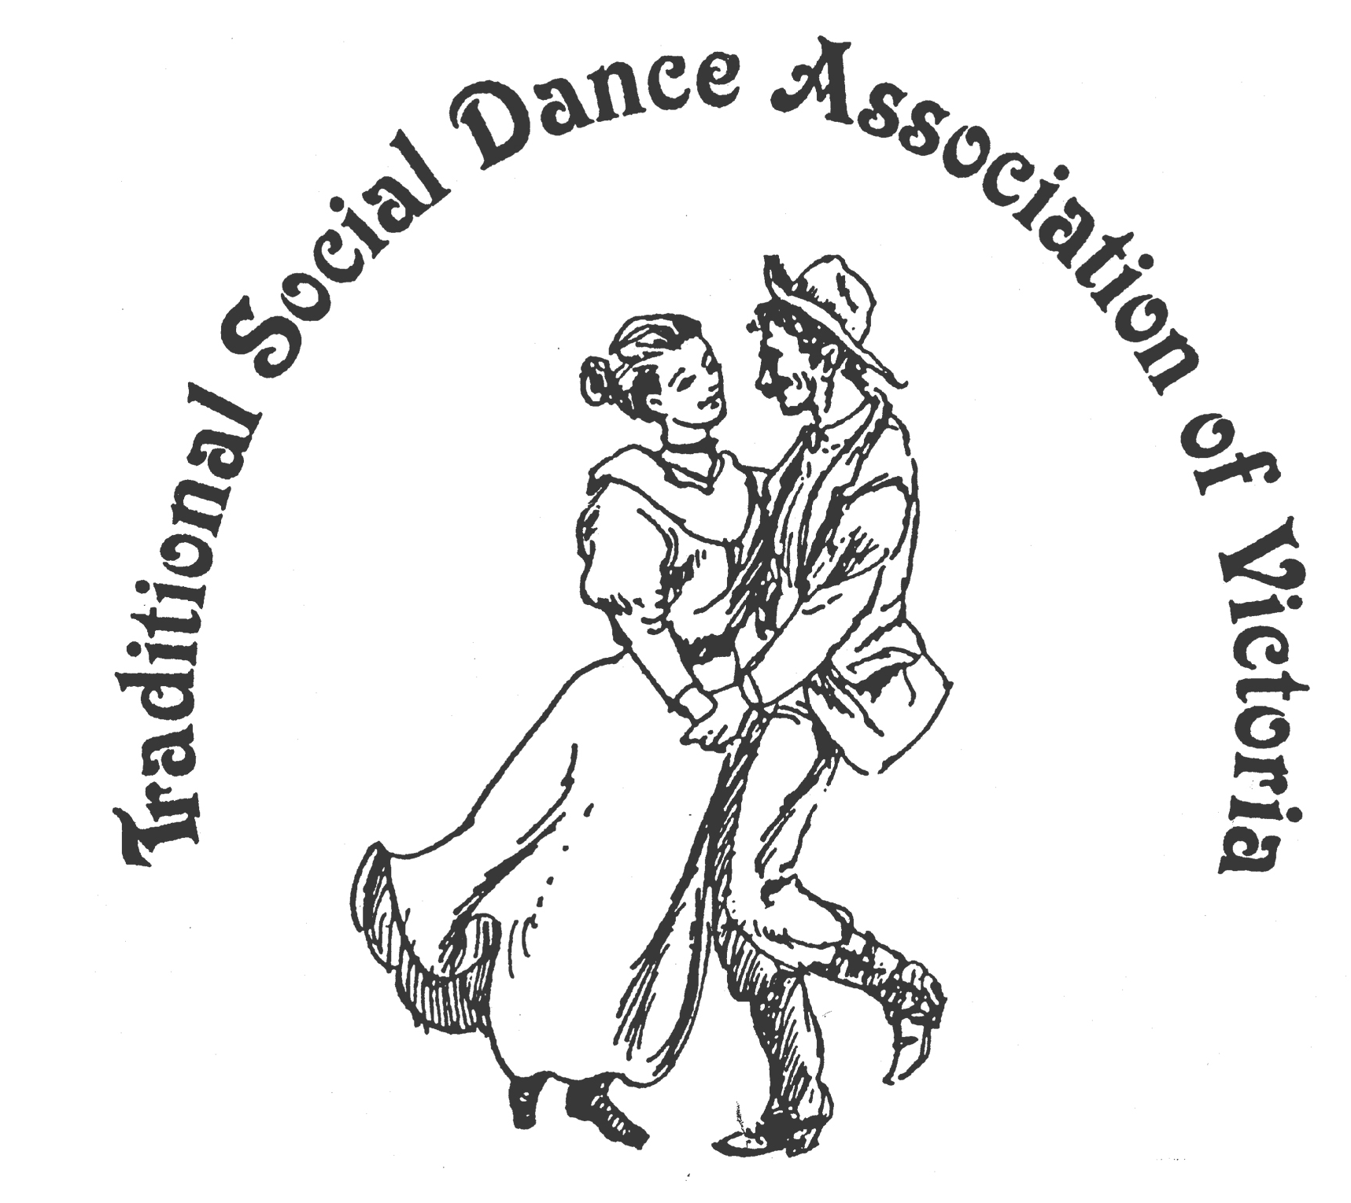
TSDAV
SPRING DANCE WEEKEND
8 - 10 November 2013 202012013201320131

Foreshore Community Hall, Portarlington

1.5 hrs drive SW of Melbourne, past Geelong, Melways 239 F2

Evening Dances on Friday and Saturday
Dance Workshops
Contradances with Jeanette Mill (Canberra)
Nordic Dances with Roger Gifford (Canberra)
Old Time Dances with Ina Bertrand (Melb)
English Country Dances (for Pride and Prejudice Anniversary) with George Ansell (Melb)
and more
Contradance music workshop with Rob Mahoney

Fun, laughter, good dancing,
good times, good friends!
NOT TO BE MISSED

For Information : info@tsdav.asn.au; www.tsdav.asn.au
Marion Stabb - (03) 9439 7100
George Ansell - (03) 98905650
TSDAV
SPRING DANCE WEEKEND
8 - 10 November 2013 202012013201320131

Foreshore Community Hall, Portarlington

1.5 hrs drive SW of Melbourne, past Geelong, Melways 239 F2

Evening Dances on Friday and Saturday
Dance Workshops
Contradances with Jeanette Mill (Canberra)
Nordic Dances with Roger Gifford (Canberra)
Old Time Dances with Ina Bertrand (Melb)
English Country Dances (for Pride and Prejudice Anniversary) with George Ansell (Melb)
and more
Contradance music workshop with Rob Mahoney

Fun, laughter, good dancing,
good times, good friends!
NOT TO BE MISSED

For Information : info@tsdav.asn.au; www.tsdav.asn.au
Marion Stabb - (03) 9439 7100
George Ansell - (03) 98905650

