~ ~ ~ TICKETS NOW AVAILABLE ~ ~ ~
~ provisional program overpage ~

OLD TIME TEA DANCE

Saturday 22nd August 2015

A tribute to Peter Ellis
1946 - 2015

Dancing 4.30 pm till around 9.30 pm

Music by

The Gay Charmers and Friends

St David’s Uniting Church Hall
74 Melville Rd, Brunswick West
(between Victoria and Hope Sts, Melways 29C6)

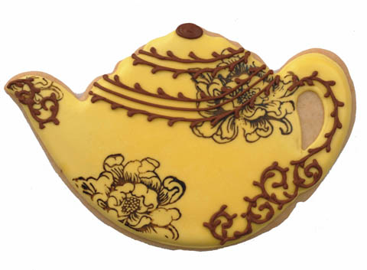

Tea & coffee provided
Please bring tea-time goodies to share

Tickets: $20 at door
$15 pre-paid

Information:
http://tsdav.asn.au/
Norm Ellis 9888 5332, Marion Stabb 9439 7100

Old Time Tea Dance

Sat. 22nd August 2015

at St David’s Uniting Church Hall, 74 Melville Rd. Brunswick West

with music by

The Gay Charmers & Friends

* Provisional Program *

ie “the programme will be chosen from the following list”

*PROGRAMME*

1 Circular Waltz (x1) Valeta Waltz (x2)
2 Boston Two Step (x2) Evening Three Step (x2)
3 Grand March into The First Set of Quadrille (5 figs-TYP)

4 Maxina (x3)
5 Swedish Country Dance (4x48b) (OR Dashing White Sergeant)
6 Waltz Cotillion (4x128b)
7 Fox Trot – Monte Carlo (prize)

8 Barn Dance (with prizes) Progressive Jive (x1)
9 St Bernard’s Waltz (x2) Waltz Oxford (x2)
10 Virginia Reel (7x RJM)
11 Varsovienna (x2)

‘Tea Time’ (~30 mins)

12 Pride of Erin (x3) (last round in 6/8)
13 Gay Gordons (x2)
14 The Prince Imperials Quadrille (5 figs)

15 Highland Schottische (x2) Princess Polka (x2)
16 Charmaine (x2) Parma Waltz (x2)
17 The Lancers (5 figs)

18 Chain Double Quadrille (6x48b)
19 Gypsy Tap (x2) 4 Sisters Barn Dance (x2) OR Canadian 3 Step (x2)
20 Swing Waltz (x3)

Auld Lang Syne Advance Australia Fair

? spare Guaracha (aka Spanish) Waltz (6x32b) (3 couple longways)

* To be confirmed

