~ Preliminary Notice ~

OLD TIME TEA DANCE

Saturday 22nd August 2015

A tribute to Peter Ellis
1946 - 2015

Dancing 4.30 pm till around 9.30 pm

Music by

The Gay Charmers and Friends

St David’s Uniting Church Hall
74 Melville Rd, Brunswick West
(between Victoria and Hope Sts, Melways 29C6)

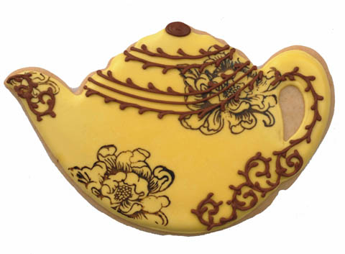

Tea & coffee provided
Please bring tea-time goodies to share

Tickets: $20 at door
$15 pre-paid

Information:
http://tsdav.asn.au/
Norm Ellis 9888 5332, Marion Stabb 9439-7100

