TSDAV presents

The OLD TIME TEA DANCE

Saturday 27th, August 2016

Dancing 4.30 pm till around 9.30 pm

Music by

The Gay Charmers and Friends

St David’s Uniting Church Hall
74 Melville Rd, Brunswick West
(between Victoria and Hope Sts, Melways 29C6)

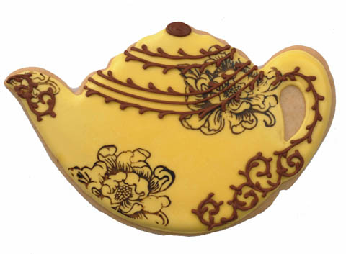

Tea & coffee provided
Please bring tea-time goodies to share,
- ready to serve ! -

Tickets: $20 at door
$15 pre-paid

Information:
http://www.tsdav.asn.au/

Norm Ellis 9888-5332, Marion Stabb 9439-7100

