ABC’s Radio National : BUSH TELEGRAPH
Wattle Day welcomes Spring Friday 6 September 2013 11:40am
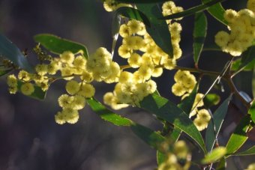
All over the world there are festivals and ceremonies to welcome in the spring.
One of the first signs of spring in Australia is the blossoming of wattle trees; "Wattle Day" is a celebration of the changing season and an excuse to indulge in some colonial traditions like bush dancing, folk singing and billy boiling.
But are these activities still relevant to modern Australia?
For the last three years folk singers and traditional dancers in Melbourne have hosted a festival that is evidence these old time traditions still have a lot to offer city folk.
Harry Gardner is president of the Victorian Folk Music Club which has been active since 1959.
"When it first started it was a kind of national expression to restore folk music; for many years it plodded along, now we're in a state of revival, we have no less than 150 playing functions each year, so we're active!"
He says Wattle Day has a special role to play in Australian culture.
"Australia Day is not enough, and it only celebrates one particular aspect of Australia, we are hoping Wattle Day will celebrate the land, the country and the people who were here before us."
The Traditional social Dance Association of Victoria has a special selection of wattle themed dances to perform on the day.
Norm Ellis, an instructor from the association, says dancing has always played an important role in people's lives, wherever they're from.
"Go back 100 years, before we had television, let alone iPods and all those other electronic devices, the whole social lubricant was dancing, everybody used to go along for the monthly dance wherever it was, all the kids, all the grannies, everybody.
"I also teach a class for retirees and it ticks all the right boxes there; it's dancing not only with the feet, but with the brain, so it's physical exercise, mental exercise and it's social interaction.
"There's no reason that shouldn't be the case for any age group, city or country."
Mr Ellis says he hopes the celebration is a nice distraction for people on election day.
"I hope it's an enjoyable day and an enjoyable relief from the tyranny of the election campaign.
"What better way to celebrate election day than to come together and have a dance, it doesn't matter who wins, we're apolitical when you get out on the dance floor."
Norm Ellis, Traditional Social Dance Association of Victoria.
Harry Gardner, president of the Victorian Folk Music Club.
Producer: Aimee Volkofsky

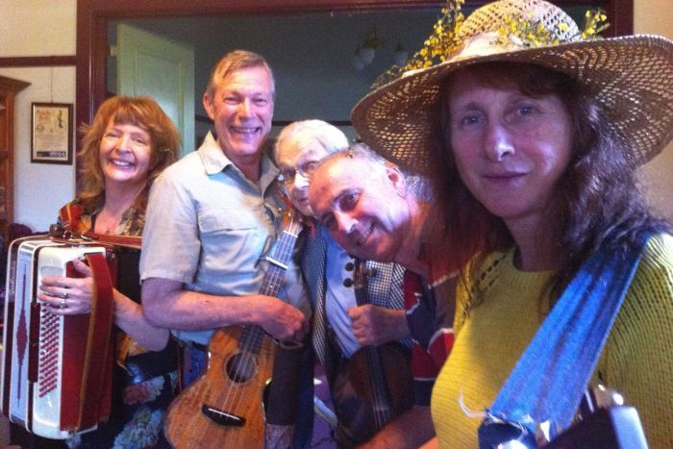
Image: Maree Buttler, Donald Fraser, Harry Gardner, Benjamin Lindner, Maggie Somerville (l to r) (photo: Aimee Volkofsky)

