Festival Prices 2014 (same as 2010!)

 | Early | On the Door
 | Bird
Weekend Ticket:  TSDAV members | $60 | $65
Weekend Ticket:  Non-members | $70 | $80
Sat all day and evening | n/a | $55
Sat evening dance only | n/a | $25  $50 (family)
Single events: | n/a | $15

Early Bird is to be fully paid on or prior to Monday 13th October 2014
Are you a member? Join now and get tickets at member’s rates
- - - - - - - - - - - - - - - - - - - - - - - - - - - - - - - - - - - - - - - - - - - - - - - - - - - - - -
APPLICATION FORM

I/we would like tickets for the
TSDAV 2013 Spring Dance Weekend
If more than one applicant, please list all names/addresses.

Name(s): __________________________ Tel: ___________

Address: _____________________________________________

Email:
Any special dietary requirements:

Number required Early Bird / Door Total
(please circle)
___ TSDAV member weekend tickets @ $60 / $65 $ ____
___ Non-member weekend tickets @ $70 / $80 $ ____
___ Saturday all-day tickets @ n/a / $55 $ ____
___ Saturday night dance only - single @ n/a / $25 $ ____
___ Saturday night dance only - family @ n/a / $50 $ ____
___ TSDAV memberships - family @ $33 $ ____
- single @ $22 $ ____
interstate - single @ $15 $ ____
Total : $ ____
Cheques/money orders, made out to TSDAV, to be sent to:
Norm Ellis, Treasurer, TSDAV, 30 Glyndon Road, Camberwell 3124
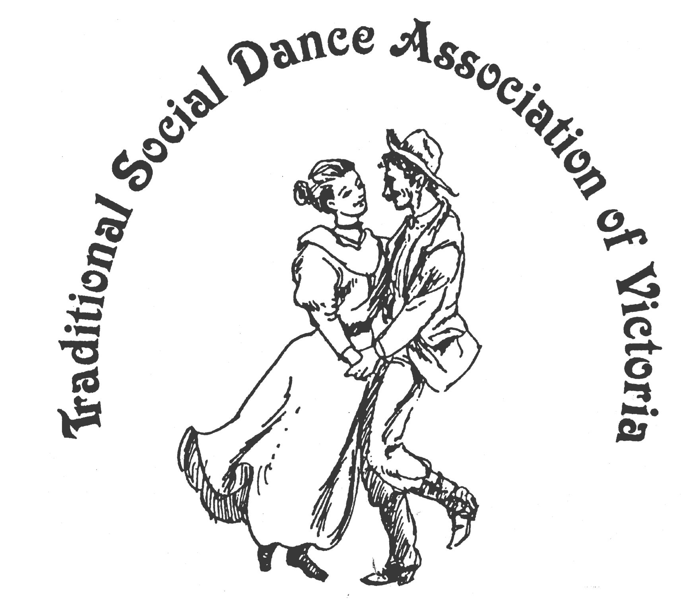
Spring Dance Weekend

7th – 9th November 2014

PARKS HALL COMMUNITY CENTRE Portarlington

(1.5 hrs drive SW of Melbourne, 20 mins past Geelong. Melways 239 F2)
featuring
Saturday Night Social Dance
“Roaring TWENTIES”
to celebrate 20 years of dance
weekends at Portarlington

Live music with Matthew Robertson,
Duncan Smith and Julia Arnold

Dance Programme
Friday night: Welcome Dance and Registration with drinks and nibbles
Saturday night: Social Dance - “Roaring TWENTIES”
Workshop Programme
Saturday/Sunday: 6 dance workshops, 1 music workshop,
Dancers’ request session
For Information: Marion Stabb - (03) 9439 7100 George Ansell - (03) 9890 5650
Website: tsdav.vicnet.net.au

Supported by bellarine bayside

Our Programme for the Weekend
Day | Event | Performer, Musician and Topic
Friday night | Registration  from 7.30 pm | With drinks and nibbles
 | Welcome Dance  from 8.00 pm | Informal night of dancing  with guest callers
Saturday | Registration  from 9.00 am
 | Dance Workshop  9.15 – 10.45 | Scottish Country Dance |  | Matt Robertson (Melbourne)
 | Dance Workshop  11.00 – 12.30 | Contra Dance |  | Julie Bishop  (Sydney)
 | Dance Workshop  1.45 – 3.15 | Nordic Dance |  | Roger Gifford (Canberra)
 | Music Workshop  Bayview Room.  1.45 – 3.15 | The real reel & other Scottish dance tunes |  | Matt Robertson (Melbourne )
 | Dance Workshop  3.30 – 5.00 | Gay Nineties to the Roaring Twenties |  | Peter Ellis  (Bendigo)
Saturday night | Evening Dance  from 8.00 pm |  | “Roaring TWENTIES”  to celebrate 20 years of dance  weekends at Portarlington
Sunday | Dance Workshop  9.45 – 11.15 | Swedish Hambo (interspersed with easy Nordic Dances) |  | Roger Gifford (Canberra)
 | Informal music session  10.00 – 12.00 | In the Bayview Room
 | Dance Workshop  11.30 – 1.00 | 20 more years of Dance Competition winners  (Launch of Books 7, 8 & 9) |  | Norm Ellis  (Melbourne)
 | Weekend Finale  2.00 – 3.30 | Popular Dances from the weekend |  | Followed by Farewell Afternoon Tea

accommodation: Ring contacts listed on front page if needing information

Food Arrangements
All morning & afternoon teas: Provided by the TSDAV
Lunches: From a local bakery – can be ordered at the hall
Saturday evening: Light supper provided during evening dance
Cafes, restaurants, hotels etc. are available in town.

OUR PRESENTERS
Norm Ellis was a founding member of the TSDAV, along with Shirley Andrews and Bruce McClure. Norm is a keen dancer, caller and dance teacher of many years standing, and also instigated the Dance Composers’ Competition. He will present a surprise selection of dances from the last 20 years of our competition – “The Best of the Best!”. Norm’s workshop will also serve as the Book Launch for the new TSDAV Dance Composers Books 7-9.
Peter Ellis has been an avid collector and instructor of traditional and old time social dances and the related music in Australia since the late 1970s. He has presented numerous workshops at many folk festivals including the National, Maldon and Port Fairy. Peter's exploits include the Wedderburn Oldtimers Orchestra, Emu Creek Bush Band and involvement in the Bush Dance and Music Club of Bendigo. Peter has produced numerous recordings of music for quadrilles, couple dances and country dances. Also a historian on the early social dance and music, Peter regularly provides articles and photographic material for the national monthly publication of Trad & Now. His workshop 20 years ago was titled “Social dances of the 1920s”.
Roger Gifford has been for the past decade the convener of sCanDans the Canberra Scandinavian Folk Dance Group and dancer/caller of a variety of styles of folk dance. He is also one of the regular callers for the Canberra Contra Club. Roger started his folk dance experience in about 1960 with Scottish Country dancing in Sheffield, England. From this beginning he consolidated his Scottish Country dancing, then branched out in the late 60s into various folk styles at Cornell University, New York. In Australia, since 1970, he has been in various display teams, focussing during the past decade with Christine Ridgway on Scandinavian Dance displays and workshops.
Matthew Robertson is well known as a Scottish dancer, dance teacher and fiddler in Melbourne and far beyond. His interest in the musical pulse of traditional social dance has taken him to four continents to perform and learn. With a wealth of experience in Scottish dance, dance performance and teaching, and a passion for its related fiddle and instrumental music, including leading bands and ensembles large and small, he is in demand as a fiddler, band leader, caller and teacher for Scottish ceilidh and country dances, and at festivals and special events.
Julie Bishop introduced contra dance to Sydney in 1990, after she and Alex had lived for two years in Palo Alto, California. Until recently she has been Sydney's only dedicated contra dance caller, and the resident caller for the annual Sydney, Gosford and Newcastle contra dances. She has presented contra workshops at many folk festivals, including the National. Currently Julie and Alex are also leaders of the revived Sydney Playford Dance Group.

