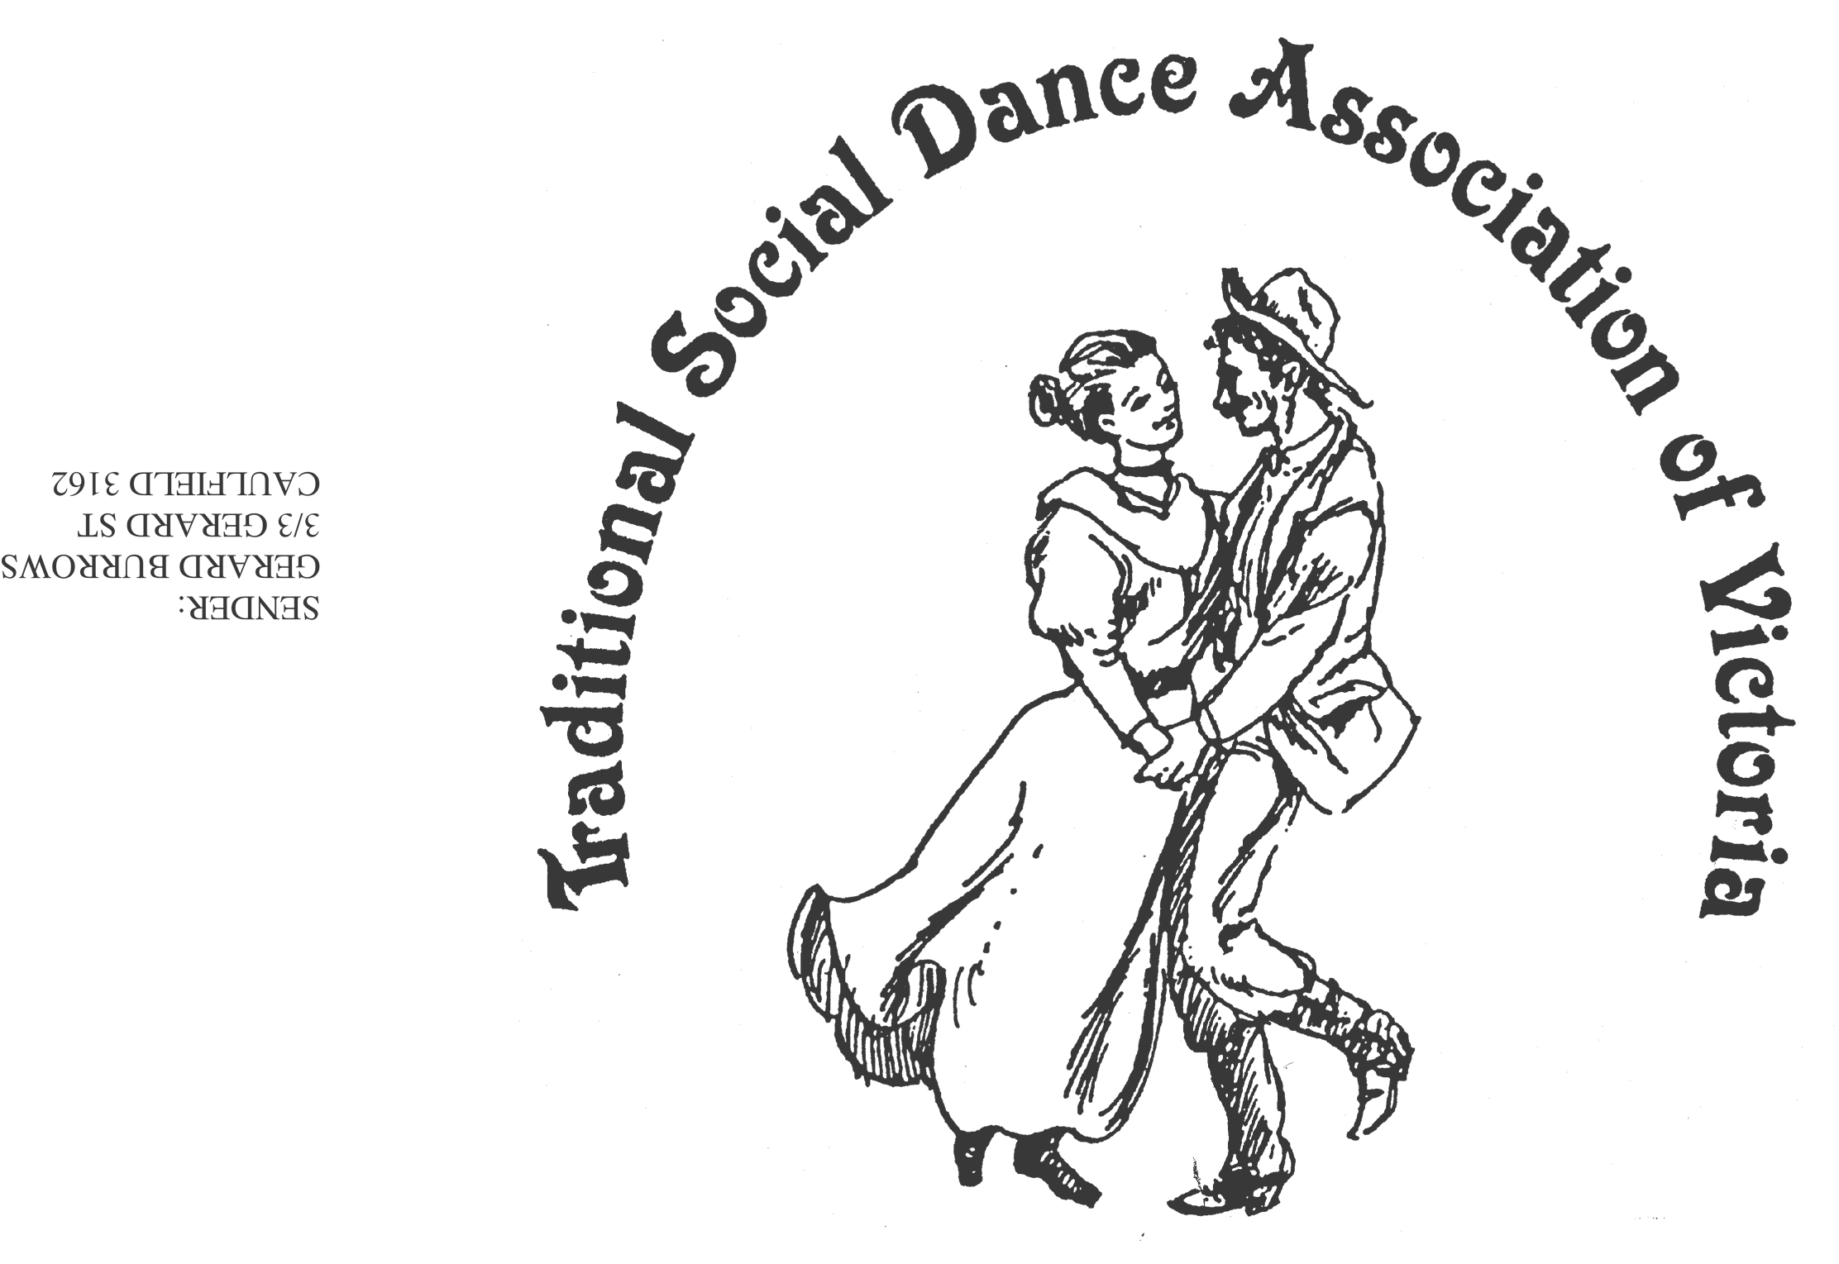Spring Dance Weekend

**8th–10th November 2024**

**PARKS HALL COMMUNITY CENTRE**

**Portarlington**

(1.5 hrs drive SW of Melbourne, 20 minutes past Geelong. OR *catch the ferry!*)

A Touch of Pearl!

Celebrate 30 years at Portarlington

Dance workshops: Sheree Hill (English & Contra), Norm Ellis (Australian),

Anne Archdeacon (Modern English), Vasilios Tsalkos (Greek), Kim South (Scottish)

*PLUS two evenings of social dancing*

*And a Dance Music Workshop*.

***Dance Programme***

Friday Evening: **Welcome Dance** and Registration with drinks and nibbles

Saturday Night: Celebrate 30 years with a **Dance Social** *~ with guest musicians*

Sunday Afternoon: Wind down with a **Farewell Dance**

***Workshop Programme***

Saturday/Sunday: 6 dance workshops, 1 dance music session

***For Information****: Norm Ellis 03 9888 5332*

*or George Ansell 03 9890 5650*

*or Judith Baillie 0431 188 026*

**Website:** [**http://tsdav.asn.au/events**](http://tsdav.asn.au/events)