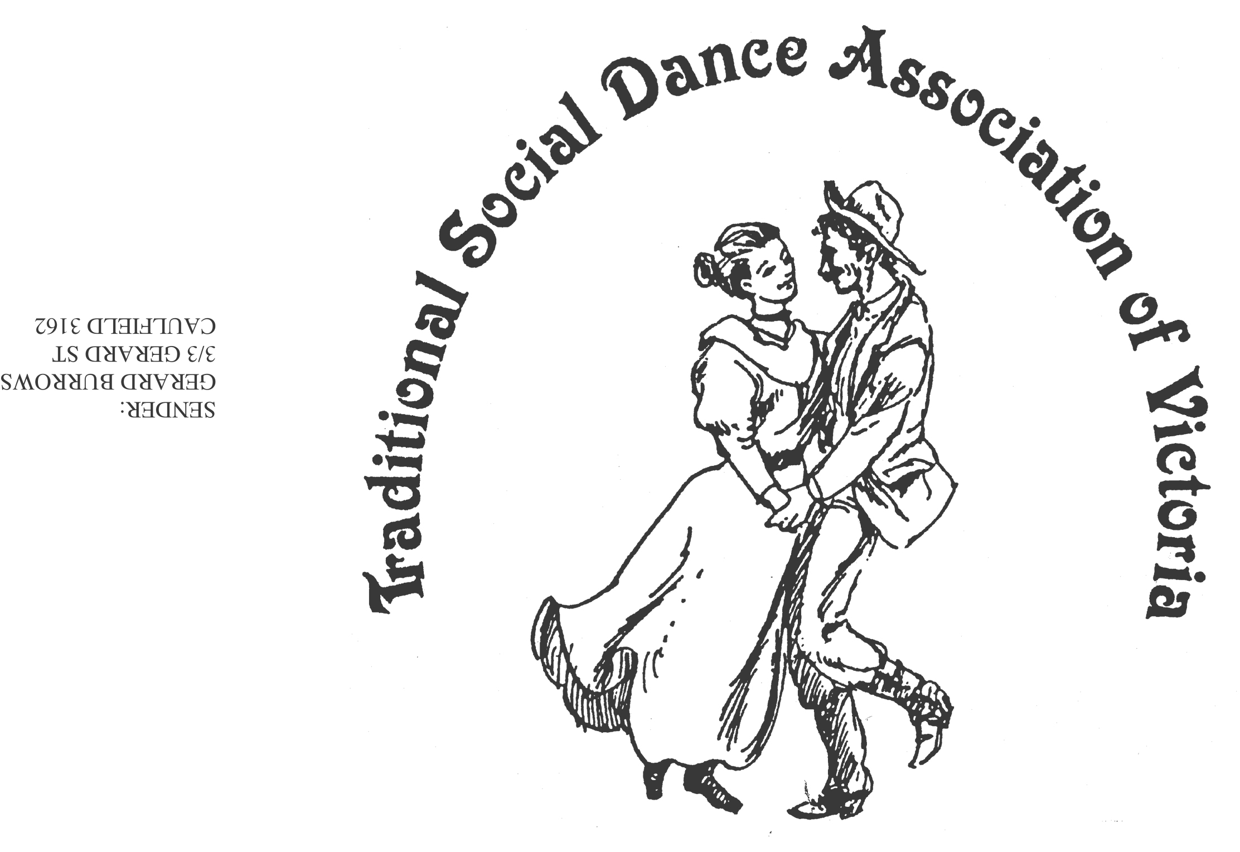
NEW DANCE COMPETITION

The Traditional Social Dance Association of Victoria Inc. holds an annual competition for dance composers,
which has been judged each year recently at the National Folk Festival.

Advance notice of the 2016 competition

There are two awards in the competition -

- General Social Dance (including Children’s Dances)
The winner of dances judged to be in this category will be awarded
the Beat Klippel Memorial trophy

- Dance for More Experienced Dancers
The winner of dances judged to be in this category will be awarded
the VFMC Perpetual Trophy

Entries are to be received by the 20th February 2016

and sent to the TSDAV c/- George Ansell
62 Wellman St. Box Hill South, VICTORIA 3128
or electronically, to - george.ansell@bigpond.com

It is really important for all entrants to obtain a copy of the Rules and Conditions
of the competition, from either the website, the above email address
or by phoning George Ansell on 03 9890 5650.

Sponsored by the Victorian Folk Music Club Inc (VFMC)
www.tsdav.asn.au
NEW DANCE COMPETITION

The Traditional Social Dance Association of Victoria Inc. holds an annual competition for dance composers,
which has been judged each year recently at the National Folk Festival.

Advance notice of the 2016 competition

There are two awards in the competition -

- General Social Dance (including Children’s Dances)
The winner of dances judged to be in this category will be awarded
the Beat Klippel Memorial trophy

- Dance for More Experienced Dancers
The winner of dances judged to be in this category will be awarded
the VFMC Perpetual Trophy

Entries are to be received by the 20th February 2016

and sent to the TSDAV c/- George Ansell
62 Wellman St. Box Hill South, VICTORIA 3128
or electronically, to - george.ansell@bigpond.com

It is really important for all entrants to obtain a copy of the Rules and Conditions
of the competition, from either the website, the above email address
or by phoning George Ansell on 03 9890 5650.

Sponsored by the Victorian Folk Music Club Inc (VFMC)
www.tsdav.asn.au
About the T.S.D.A.V.

Since its formation in 1980, the Traditional Social Dance Association
of Victoria (T.S.D.A.V.) has been involved in the collecting, promoting, presentation and preservation of our traditional social dance heritage.
To this end, it runs classes at festivals, dance weekends & dance days, social dances,as well as regular dance workshops through the Victorian Dance Assembly (VDA). It also runs the annual Dance Composers’ Competition,
for contemporary folk dances written in the style of traditional dances.
In latter years, this has been judged at the National Folk Festival, held in Canberra.

The main styles of dancing promoted through these events have been traditional Australian (Colonial), Old Time, English, Irish, and Scottish.
More recently we have added Welsh and (New England style) Contra.

The T.S.D.A.V.'s main aims are
- To promote interest in traditional social dancing,
- To improve the knowledge and standard of social dancing,
- To encourage dancing in a correct traditional style.

The TSDAV and VDA have also produced a number of dance publications.
These are available for purchase.



THE DANCE COMPOSERS’ COMPETITION

“Australian Contemporary Folk Dances”

The T.S.D.A.V. Dance Composers’ Competition aims to promote the
composition of contemporary dances written in a traditional style.
Up until 1994 there was just one category. Since 1995 however,
there have been two judging categories in the Competition, for:
- General Social Dances (including Children's Dances)
- Dances for More Experienced Dancers.

Thanks are due to the Victorian Folk Music Club (V.F.M.C.) for their
continued support in providing the Beat Klippel Memorial Plaque
for the best dance in the General Social Dance category,
and the V.F.M.C. Perpetual Trophy for the winner of the dance
in the More Experienced Dance category,
as well as for the medallions which are presented to each of the winners.


About the T.S.D.A.V.

Since its formation in 1980, the Traditional Social Dance Association
of Victoria (T.S.D.A.V.) has been involved in the collecting, promoting, presentation and preservation of our traditional social dance heritage.
To this end, it runs classes at festivals, dance weekends & dance days, social dances, as well as regular dance workshops through the Victorian Dance Assembly (VDA). It also runs the annual Dance Composers’ Competition,
for contemporary folk dances written in the style of traditional dances.
In latter years, this has been judged at the National Folk Festival, held in Canberra.

The main styles of dancing promoted through these events have been traditional Australian (Colonial), Old Time, English, Irish, and Scottish.
More recently we have added Welsh and (New England style) Contra.

The T.S.D.A.V.'s main aims are
- To promote interest in traditional social dancing,
- To improve the knowledge and standard of social dancing,
- To encourage dancing in a correct traditional style.

The TSDAV and VDA have also produced a number of dance publications.
These are available for purchase.



THE DANCE COMPOSERS’ COMPETITION

“Australian Contemporary Folk Dances”

The T.S.D.A.V. Dance Composers’ Competition aims to promote the
composition of contemporary dances written in a traditional style.
Up until 1994 there was just one category. Since 1995 however,
there have been two judging categories in the Competition, for:
- General Social Dances (including Children's Dances)
- Dances for More Experienced Dancers.

Thanks are due to the Victorian Folk Music Club (V.F.M.C.) for their
continued support in providing the Beat Klippel Memorial Plaque
for the best dance in the General Social Dance category,
and the V.F.M.C. Perpetual Trophy for the winner of the dance
in the More Experienced Dance category,
as well as for the medallions which are presented to each of the winners.



