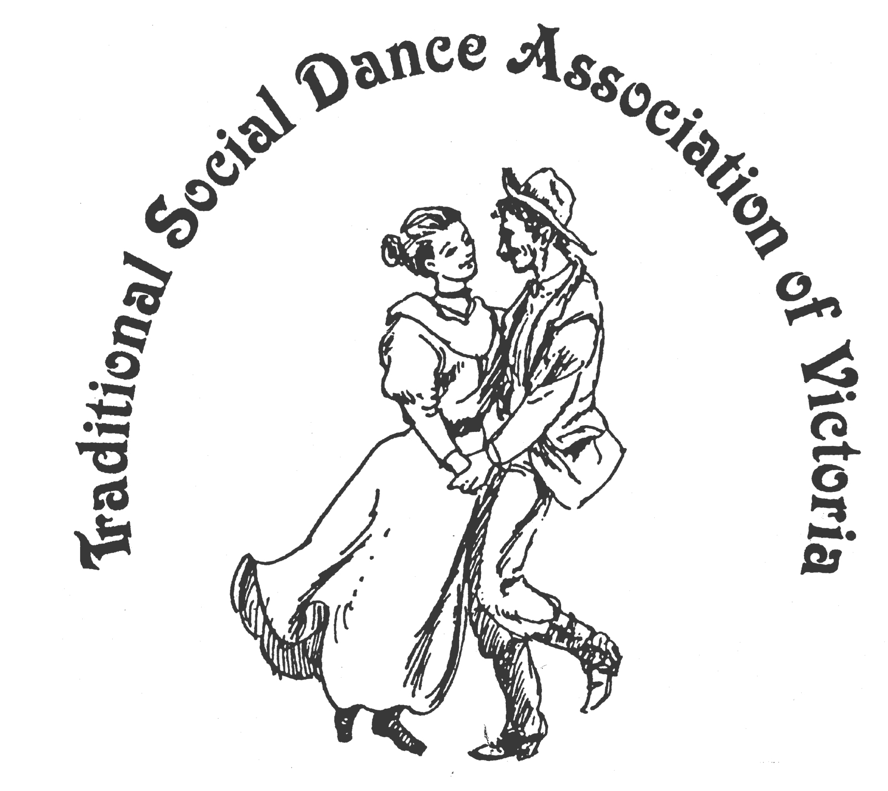
TSDAV
SPRING DANCE WEEKEND
6 - 8 November 2015
Foreshore Community Hall, Portarlington
Celebrating 20 Years at Portarlington
1.5 hrs drive SW of Melbourne, past Geelong, Melways 239 F2

Dance Workshops
Australian Dances with Don Richmond (Sydney)
Irish Set & Ceili Dances with Marie Brouder (Melb)
French Dances with Valeria and Matteo (Italy/Melb)
Israeli Dancing with Richelle (Melb Zooz group)
Square Dancing and more!

Friday Evening Dance
Saturday Evening Dance: “Around the World in 80 Dances” with live music:
Joan & Ray Mundy plus Nicki Kramer

*** fun, laughter, good dancing ***
*** good times, good friends ***
NOT TO BE MISSED
For Information : info@tsdav.asn.au; www.tsdav.asn.au
Marion Stabb - (03) 9439 7100
George Ansell - (03) 9890 5650

