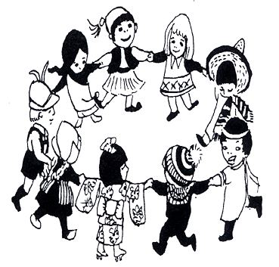

From 1986 to 2018 renowned folk-dance teacher Andre van de Plas visited Australia in July, bringing with him each time a new collection of about 20 folk dances which he taught in Canberra, Sydney, Melbourne, Hobart, Perth, Adelaide and Queensland.
A remarkable legacy of over 600 dances from the many nations of the world.
While planning his 33rd visit we received shocking news from Holland that Andre had passed away very suddenly and unexpectedly from a stroke.

Our response is “Seize the day and dance.”
So we are instituting on the first day of Spring:-
ADVP Legacy Dance Day
2.15-10.15pm
Sunday 1 September, 2019
Beckett Hall, 72 Highfield Rd Canterbury

The day’s program will consist of 4 sessions
2.15 Intermediate International Dance Workshop
4.15 All Welcome Family Folk Dance with Shenanigans Band
6.15 Potluck shared dinner and discussion
7.15 Preparation for ‘Opposite Dancing’ (Contradancing)
7.45-10.15 Contradition Contradance to live music

As our goal is to promote good will and good health through dance, not to make a profit, this will be a fun-raiser rather than a fund-raiser, so expected cost is $20/$10 permitting entrance to any/all sessions.

Stay tuned to Boite, Contradition, FDA, Shenanigans, VOSA for further information. Enrolments and tickets will be forthcoming
OR further details: Jan Turner: janturner41@gmail.com / Mobile 0407 524 278
Seize the Day Dance

Renowned folk dance teacher
Andre van de Plas (1948-2019)
introduced 675 folk dances to Australia
Come and celebrate his remarkable legacy on
Sunday 1 September
Beckett Hall, 72 Highfield Rd Canterbury
The day will consist of 3 sessions -
2.15pm A: Advanced Folk Dance Workshop ***
- for experienced dancers and teachers
4.15pm B: Bush Folk Dance with Shenanigans
Family Folk Dance. All welcome
7.15pm C: Contradance - preparation for ‘Opposite Dancing’
Monthly Contradition Dance.
At 6.15pm we have a communal Potluck Dinner
(bring something to share)

Silver wristband (any 2 sessions) $20
Gold wrist band (entire day) only $25
Tickets and individual session prices https://www.trybooking.com/BDURL

NB *** Advanced 2.15 session will be remembering Andre through dancing a request list of his dances over the years,
stopping to revise where necessary, so would be most appropriate for those who have done his workshops in the past.

Further details: Jan Turner: janturner41@gmail.com / Mobile 0407 524 278

